VISVESVARAYA TECHNOLOGICAL UNIVERSITY

“JnanaSangama”, Belgaum -590014, Karnataka.



LAB REPORT

on

Database Management Systems (23CS3PCDBM)

Submitted by

Paspula Nitish Kumar (1BM24CS199)

in partial fulfillment for the award of the degree of

# BACHELOR OF ENGINEERING

in

## COMPUTER SCIENCE AND ENGINEERING



## B.M.S. COLLEGE OF ENGINEERING

(Autonomous Institution under VTU)

BENGALURU-560019

Sep-2025 to Jan-2026

B. M. S. College of Engineering,

Bull Temple Road, Bangalore 560019

(Affiliated To Visvesvaraya Technological University, Belgaum)

### Department of Computer Science and Engineering



CERTIFICATE

This is to certify that the Lab work entitled “Database Management Systems (23CS3PCDBM)” carried out by Paspula Nitish Kumar (1BM24CS199), who is bonafide student of B. M. S. College of Engineering. It is in partial fulfillment for the award of Bachelor of Engineering in Computer Science and Engineering of the Visvesvaraya Technological University, Belgaum during the year 2022. The Lab report has been approved as it satisfies the academic requirements in respect of a Database Management Systems (23CS3PCDBM) work prescribed for the said degree.

|  |  |
| --- | --- |
| Lab faculty  Mr. Lakshman Singh  Assistant Professor  Department of CSE, BMSCE | Dr. Kavitha Sooda  Professor & HOD  Department of CSE, BMSCE |

Index

|  |  |  |  |
| --- | --- | --- | --- |
| Sl.  No. | Date | Experiment Title | Page No. |
| 1 | 26-09-2025 | Insurance Database | 4-12 |
| 2 | 10-10-2025 | More Queries on Insurance Database | 13-14 |
| 3 | 17-10-2025 | Bank Database | 15-21 |
| 4 | 24-10-2025 | More Queries on Bank Database | 22-23 |
| 5 | 31-10-2025 | Employee Database | 24-30 |
| 6 | 07-11-2025 | More Queries on Employee Database | 31-32 |
| 7 | 14-11-2025 | Supplier Database | 33-37 |
| 8 | 21-11-2025 | More Queries on Supplier Database | 38-39 |
| 9 | 21-11-2025 | NOSQL Installation in Cloud | 40 |
| 10 | 28-11-2025 | NO SQL - Student Database | 41-43 |
| 11 | 05-12-2025 | NO SQL - Customer Database | 44-46 |
| 12 | 12-12-2025 | NO SQL – Restaurant Database | 47-50 |
| 13 | 12-12-2025 | LeetCode Practice | 51-53 |
| 14 | 12-12-20256 | LeetCode Practice | 54-57 |

# Experiment 1: Insurance Database

Specification of Insurance Database Application

The insurance database must maintain information about drivers, the cars they own, the accidents reported, and the participation of each driver and car in those accidents. Each driver in the system is uniquely identified by a driver ID, along with their name and address, and each car is uniquely identified by its registration number together with details such as model and manufacturing year. The system must allow storing ownership information that links a driver to one or more cars, while also allowing a car to be linked to one or more drivers if shared ownership occurs; duplicate ownership records for the same driver and car must not exist. Accident information must be stored using a unique report number assigned to each accident, along with the date on which the accident occurred and the location where it happened. Every accident reported in the system must have at least one participating driver and car, and this participation is recorded by linking the driver, the involved car, and the accident report together with the corresponding damage amount for that particular involvement. A participation record must reference an existing driver, an existing car, and an existing accident, and no two participation entries may repeat the same combination of driver, car, and accident report. The database must ensure that damage amounts are non-negative, accident dates are valid calendar dates, and car manufacturing years fall within reasonable limits. It must also preserve referential integrity so that ownership or participation entries cannot exist without valid driver, car, and accident information already present in the system. Deletion policies must prevent removal of drivers or cars that appear in past accident participation records unless historical consistency is preserved through controlled deletion rules or archival mechanisms. The system should maintain accurate links between drivers, cars, and accidents at all times, ensuring reliable retrieval of ownership histories, accident histories, and damage information for administrative, legal, and insurance-related purposes.

## Entity Relationship Diagram Schema Diagram

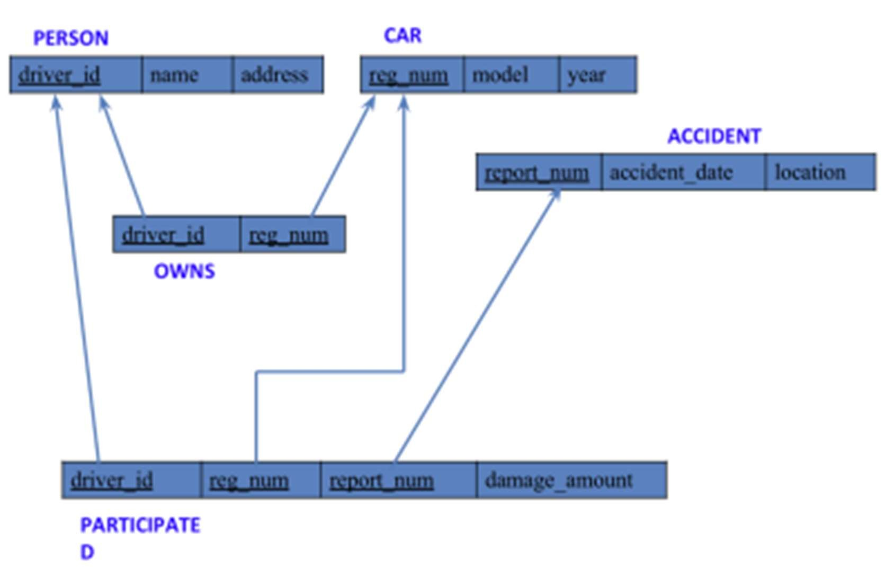

* PERSON (driver_id: String, name: String, address: String)
* CAR (reg_num: String, model: String, year: int)
* ACCIDENT (report_num: int, accident_date: date, location: String)
* OWNS (driver_id: String, reg_num: String)
* PARTICIPATED (driver_id: String,reg_num: String, report_num: int, damage_amount: int)
* Create the above tables by properly specifying the primary keys and the foreign keys. - Enter at least five tuples for each relation

## Create database

create database insurance; use insurance;

## Create table

create table person (driver_id varchar(10), name varchar(20), address varchar(30), primary key(driver_id));

create table car(reg_num varchar(10), model varchar(10), year int, primary key(reg_num));

create table accident(report_num int, accident_date date, location varchar(20), primary key(report_num));

create table owns(driver_id varchar(10), reg_num varchar(10), primary key(driver_id, reg_num), foreign key(driver_id) references person(driver_id), foreign key(reg_num) references car(reg_num));

create table participated(driver_id varchar(10), reg_num varchar(10), report_num int, damage_amount int, primary key(driver_id, reg_num, report_num), foreign key(driver_id) references person(driver_id), foreign key(reg_num) references car(reg_num), foreign key(report_num) references accident(report_num));

## Structure of the table

desc person;

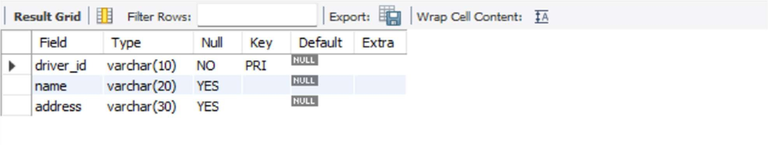

desc accident;

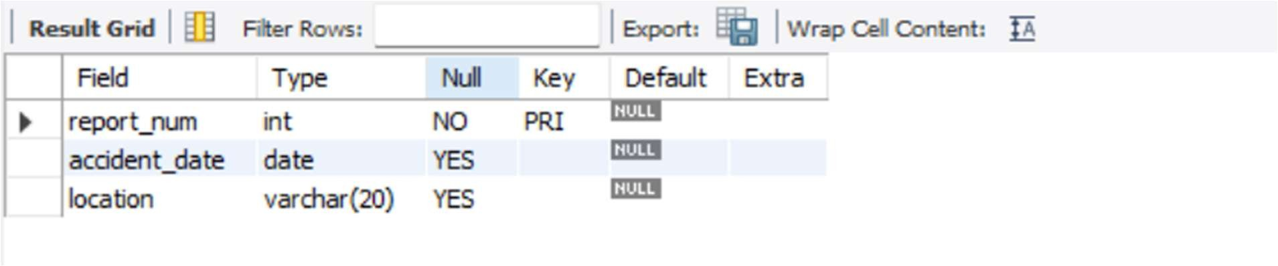 desc participated;

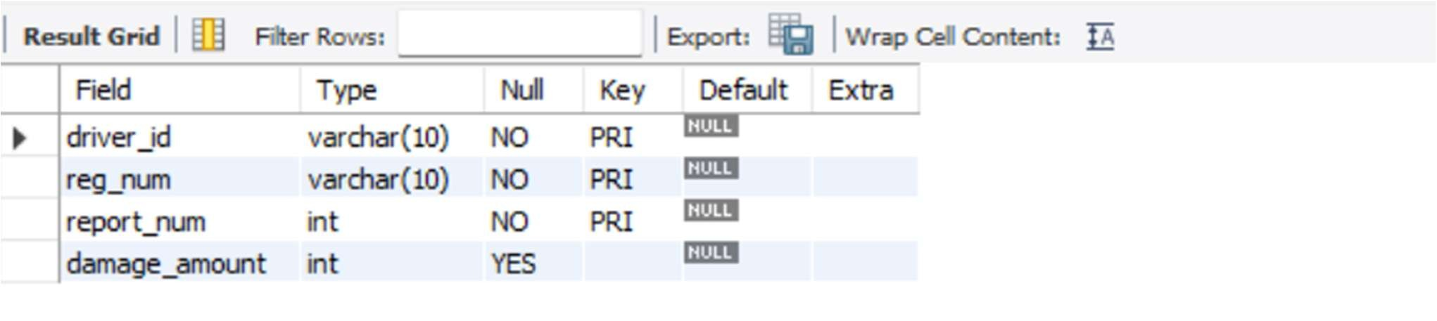

desc car;

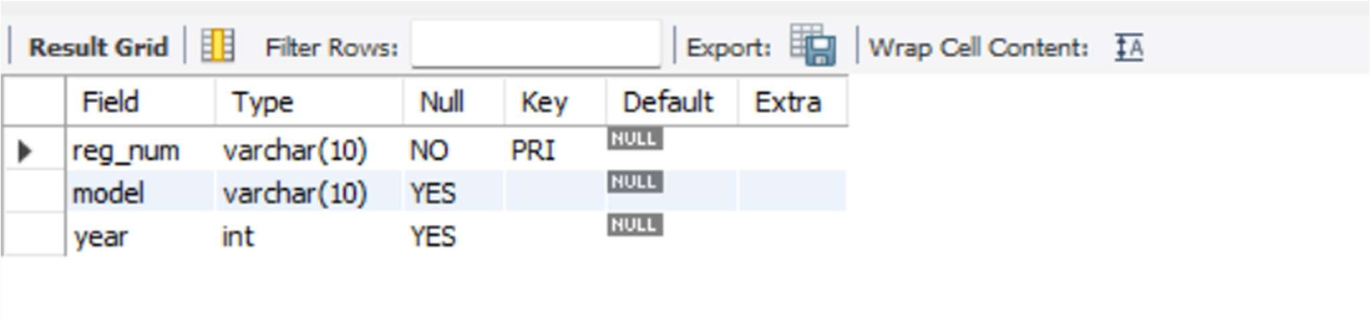

desc owns;

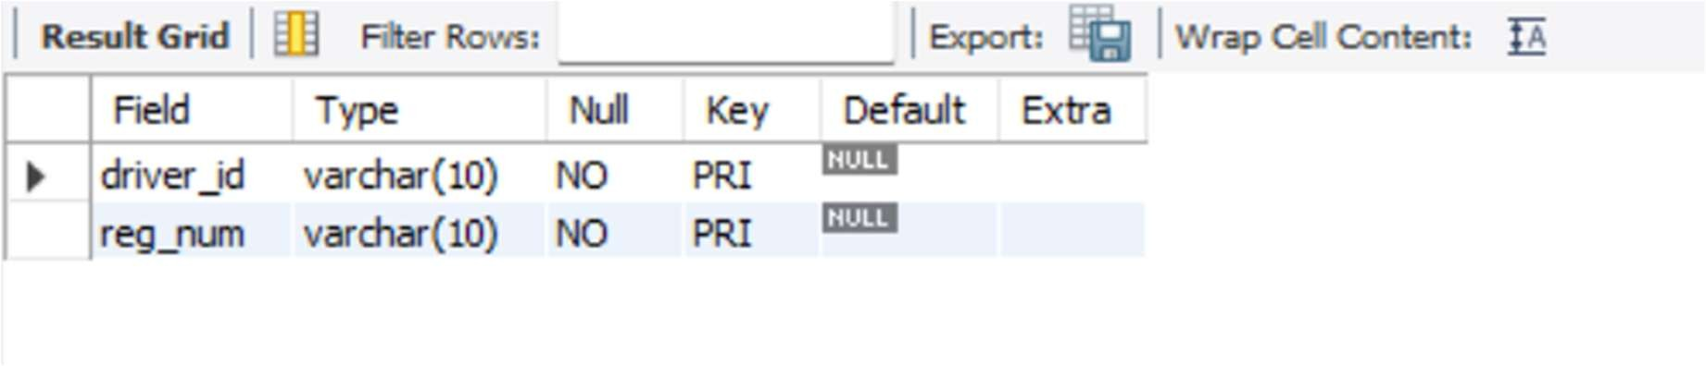

## Inserting Values to the table

insert into person values

("A01","Richard","Srinivas nagar"),

("A02","Pradeep","Rajaji nagar"),

("A03","Smith","Ashok nagar"),

("A04","Venu","N R Colony"), ("A05","John","Hunumanth nagar"); select * from person;

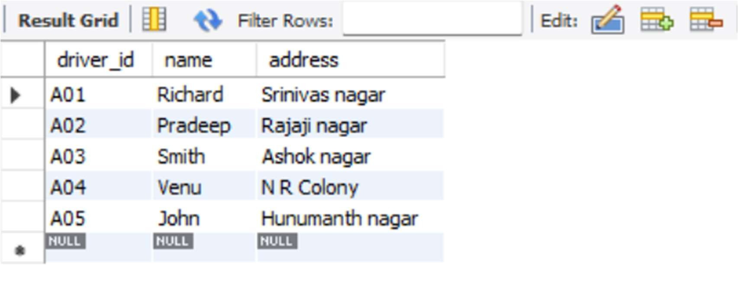

insert into car values

("KA052250","Indica",1990),

("KA031181","Lancer",1957),

("KA095477","Toyata",1998),

("KA053408","Honda",2008),

("KA041702","Audi",2005);

select * from car;

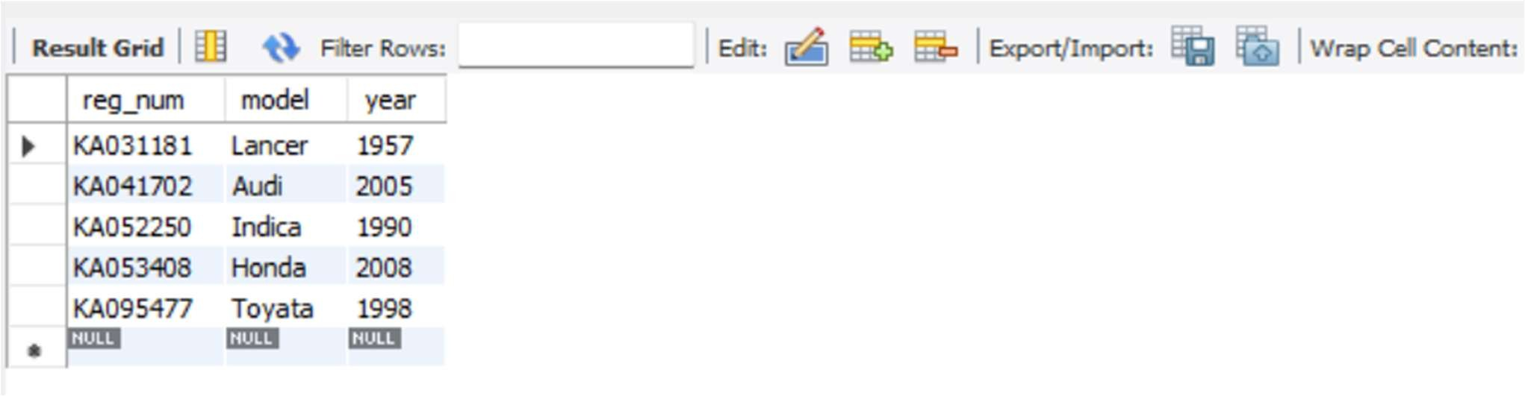

insert into owns values ('A01', 'KA052250'),

('A02', 'KA053408'),

('A03', 'KA031181'),

('A04', 'KA095477'),

('A05', 'KA041702');

select * from owns;

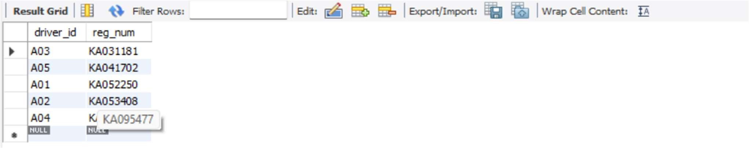

insert into accident values

(11, '2003-01-01', 'Mysore Road'),

(12, '2004-02-02', 'South end Circle'),

(13, '2003-01-21', 'Bull temple Road'),

(14, '2005-02-17', 'Mysore Road'),

(15, '2005-03-04', 'Kanakapura Road'); select * from accident;

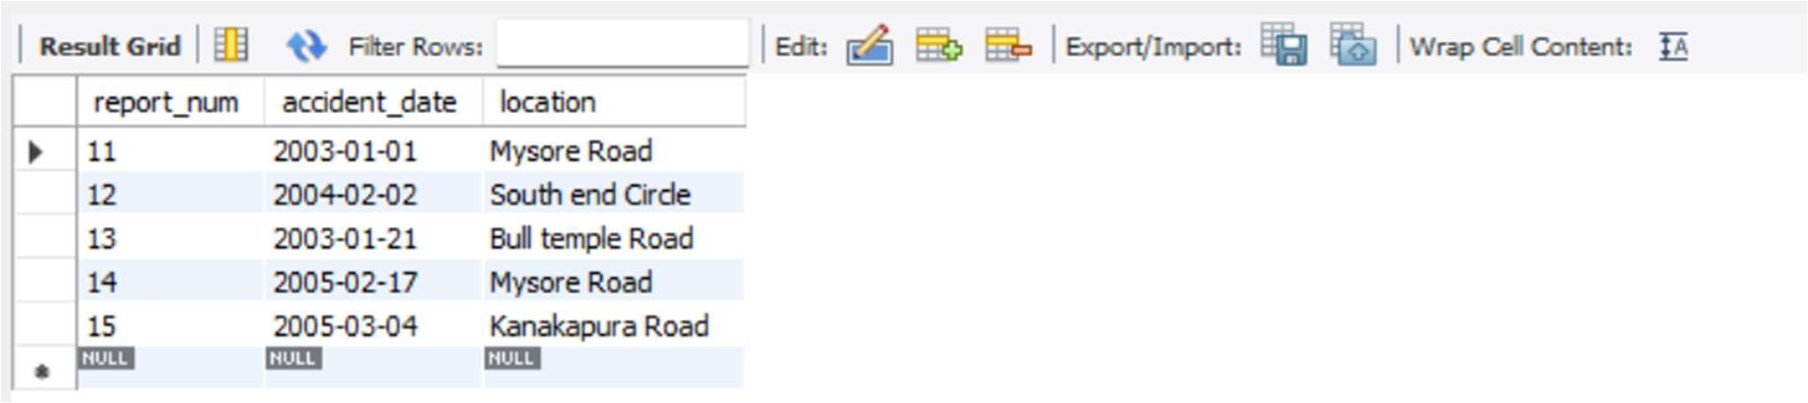

insert into participated values

('A01', 'KA052250', 11, 10000),

('A02', 'KA053408', 12, 50000),

('A03', 'KA095477', 13, 25000),

('A04', 'KA031181', 14, 3000),

('A05', 'KA041702', 15, 5000); select * from participated;

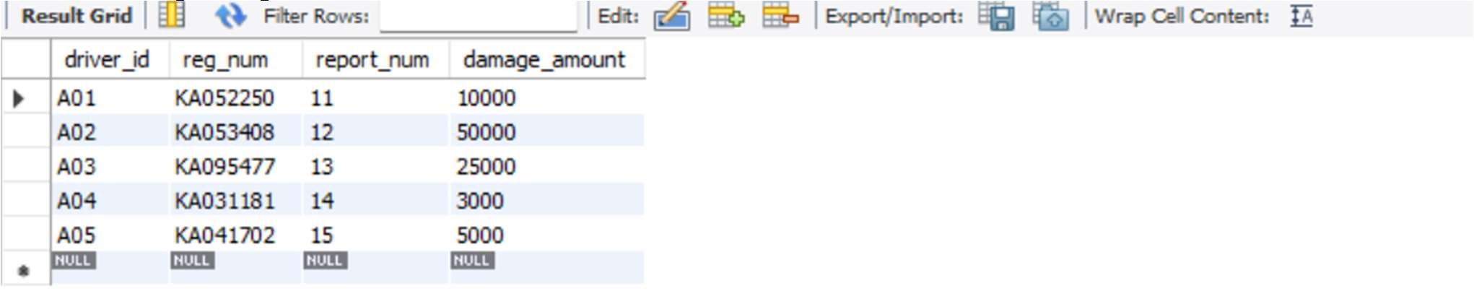

## Queries (Questions and output )

- Update the damage amount to 25000 for the car with a specific reg-num (example 'KA053408' ) for which the accident report number was 12.

update participated set damage_amount=25000 where reg_num='KA053408' and report_num=12; select * from participated;

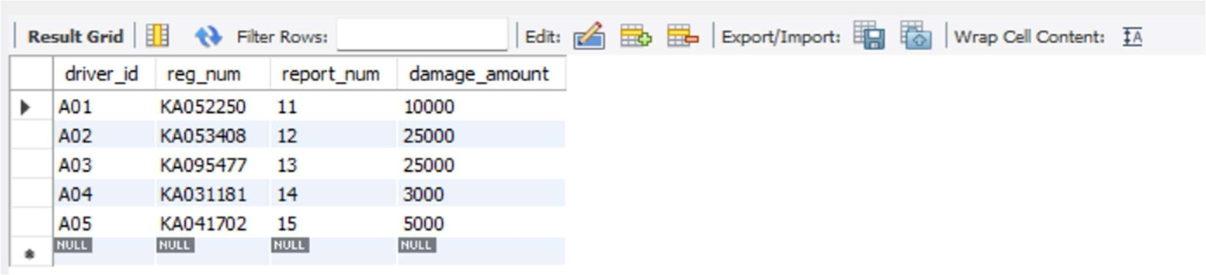

* Add a new accident to the database.

insert into accident values(16,'2008-03-15','Domlur');



* Display Accident date and location

select accident_date, location from accident;

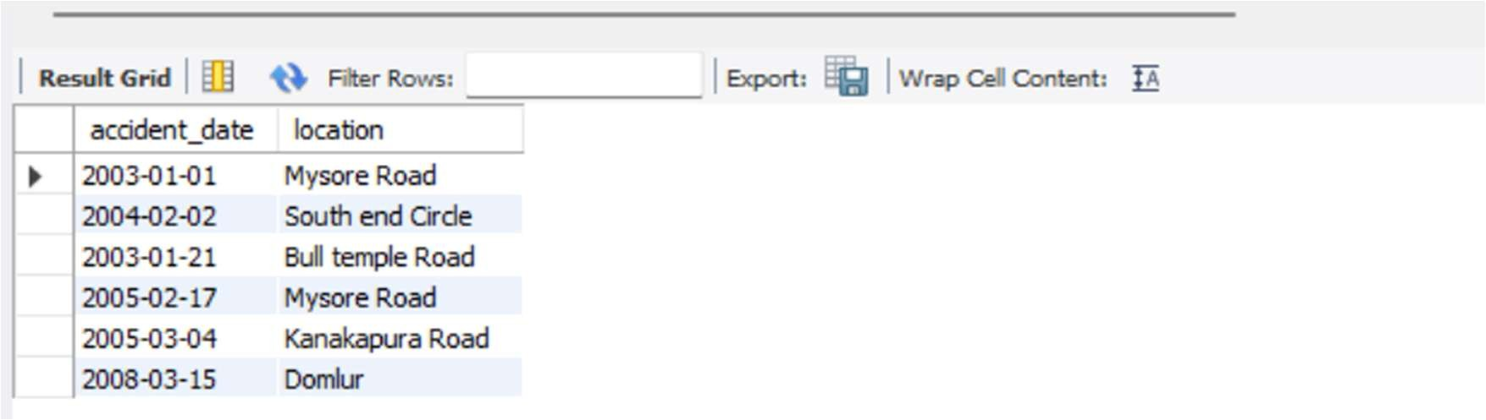

* Display driver id who did accident with damage amount greater than or equal to Rs.25000

select driver_id from participated where damage_amount >=25000;

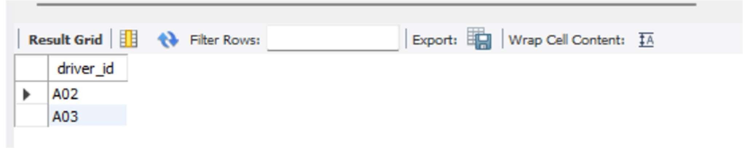

# Experiment 2: More Queries on Insurance Database

Queries and output :

* Display the entire CAR relation in the ascending order of manufacturing year.

SELECT *

FROM car

ORDER BY year ASC;

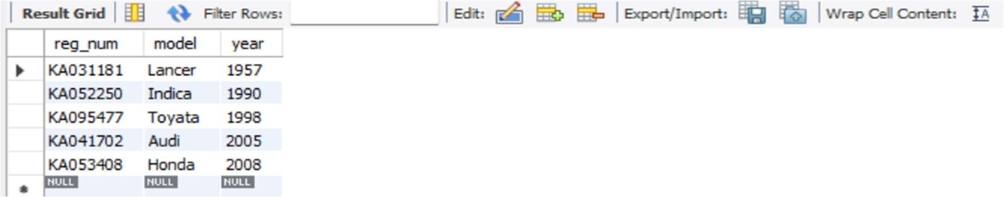

* Find the number of accidents in which cars belonging to a specific model (example 'Lancer') were involved.

SELECT COUNT(*) AS num_accidents FROM participated p

JOIN car c ON p.reg_num = c.reg_num

WHERE c.model = 'Lancer';

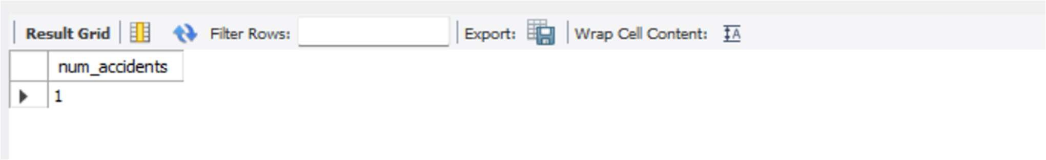

* Find the total number of people who owned cars that involved in accidents in 2008.

SELECT COUNT(DISTINCT o.driver_id) AS total_people FROM participated p

JOIN owns o ON p.reg_num = o.reg_num

JOIN accident a ON p.report_num = a.report_num

WHERE YEAR(a.accident_date) = 2008;

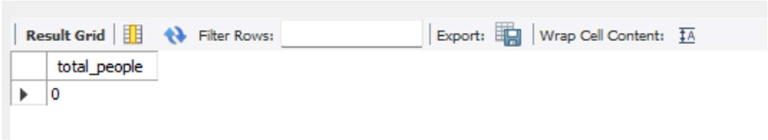

* List the entire participated relation in the Descending Order of Damage Amount.

SELECT *

FROM participated

ORDER BY damage_amount DESC;

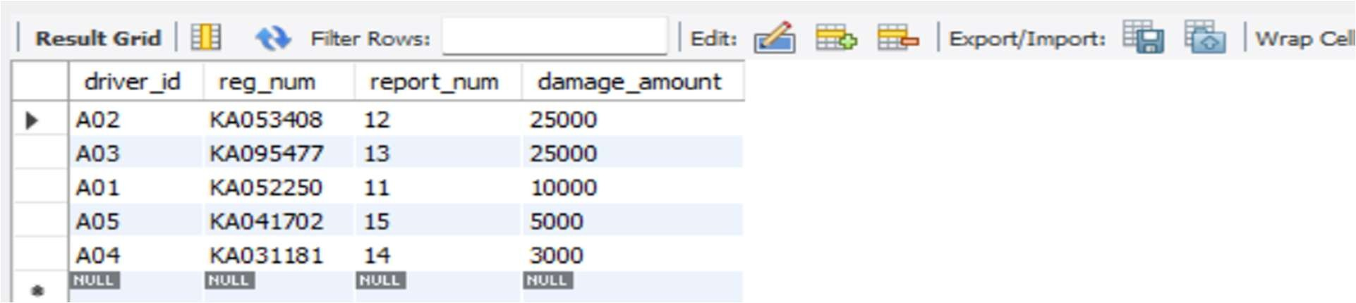

* Find the Average Damage Amount.

SELECT AVG(damage_amount) AS avg_damage FROM participated;

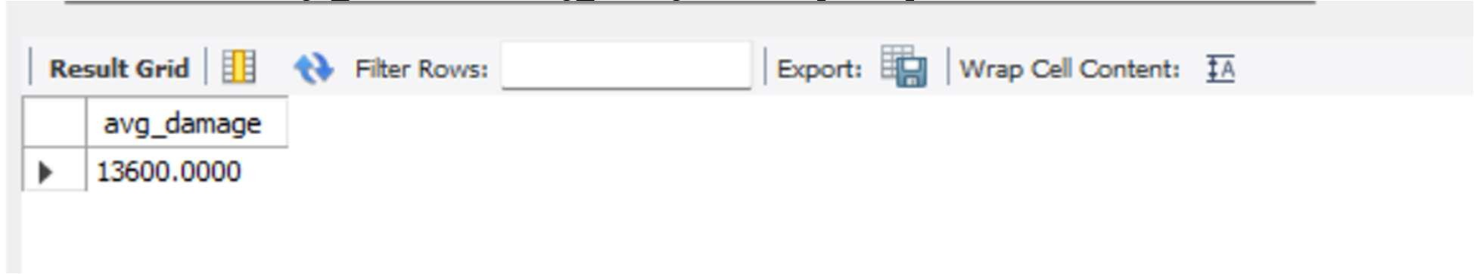

* Delete the tuple whose Damage Amount is below the Average Damage Amount

DELETE FROM participated

WHERE damage_amount < (SELECT AVG(damage_amount) FROM (SELECT

AVG(damage_amount) AS avg_damage FROM participated) AS temp);



* List the name of drivers whose Damage is Greater than the Average Damage Amount.

SELECT DISTINCT per.name FROM participated p

JOIN person per ON p.driver_id = per.driver_id

WHERE p.damage_amount > (SELECT AVG(damage_amount) FROM participated);

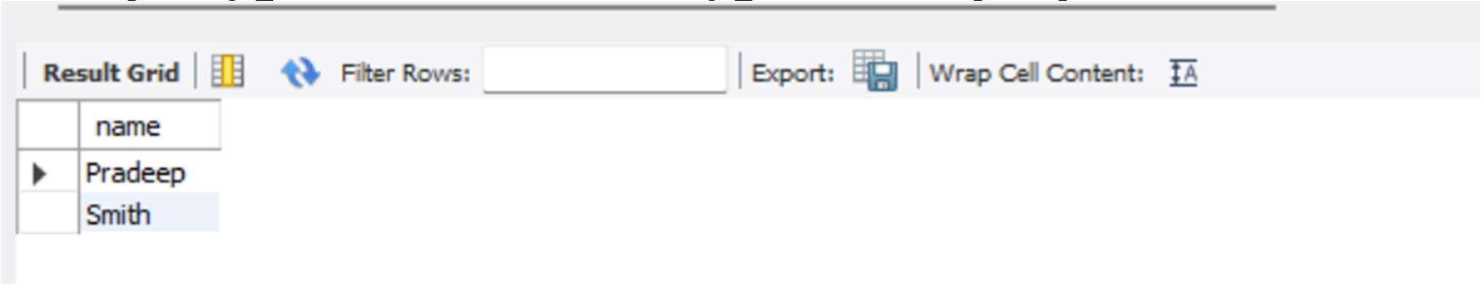

* Find Maximum Damage Amount.

SELECT MAX(damage_amount) AS max_damage FROM participated;

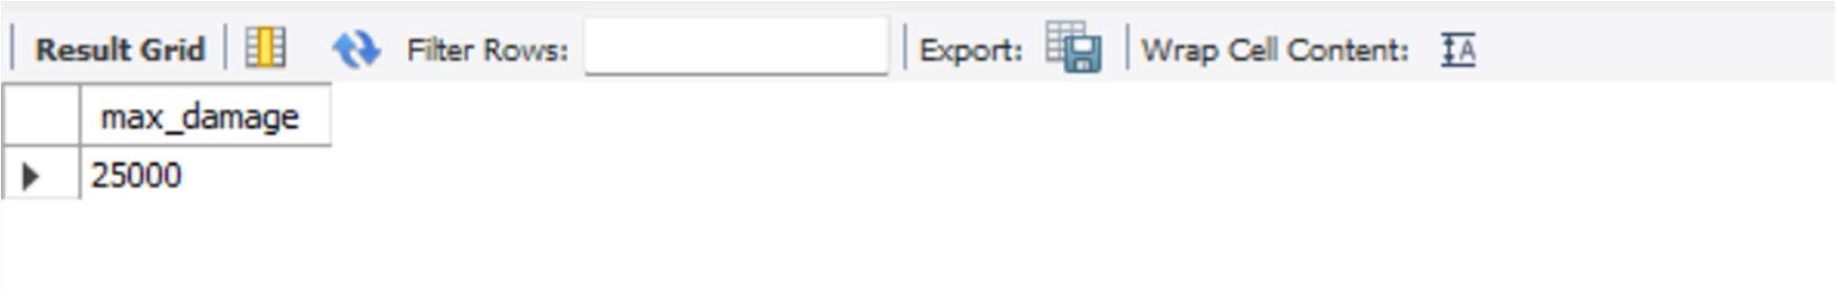

# Experiment 3:Bank Database

BANKING ENTERPRISE DATABASE

The banking system must store information about branches, bank accounts, customers, deposit relationships, and loans so that branch details (identified by branch name together with city and total assets) are linked to accounts and loans, each account (identified by an account number) records the branch it belongs to and the current balance, customers are recorded with their name, street and city, and a depositor relationship associates a customer with an account; loans are recorded by a unique loan number together with the branch name that issued the loan and the loan amount. Account numbers and loan numbers must be unique identifiers, branch names are used to associate accounts and loans to a branch, and customer names (as modeled) are used to identify customers referenced by depositor entries; every depositor entry must reference an existing customer and an existing account so that ownership and access relationships are always valid, and duplicate depositor records linking the same customer and account are disallowed. The system must maintain referential integrity so accounts cannot reference a non-existent branch, depositor rows cannot reference missing customers or accounts, and loans must reference an existing branch; deletion of a branch, account, or customer that is referenced by dependent records should be controlled (either disallowed or handled by archival/controlled reassignment) to preserve historical transaction and loan consistency. Numeric and temporal constraints must be enforced: account balances should be constrained to valid values (for example non-negative where overdraft is not allowed), branch assets and loan amounts must be non- negative and within specified business limits, and updates to balance or loan amounts should be auditable. Cardinality rules implied by the schema are enforced: a branch may host many accounts and issue many loans, an account belongs to exactly one branch, a customer may be linked to many accounts through depositor relationships, and an account may have many depositors if joint accounts are permitted by policy. Implementation must prevent orphaned records, ensure uniqueness where required, and rely on application logic or database-level triggers to enforce complex rules such as cascading effects on deletion, business rules about allowed balance operations or overdrafts, and any required validation when transferring accounts between branches or when converting a customer’s identifying details; the database should thus reliably support queries for branch-wise account lists, customer account ownership, account balances, and loan portfolios while preserving historical and referential integrity for auditing and regulatory reporting.

ER DIAGRAM RELATION SCHEMA:

Branch (branch-name: String, branch-city: String, assets: real)

BankAccount(accno: int, branch-name: String, balance: real)

BankCustomer (customer-name: String, customer-street: String, customer-city: String)

Depositer(customer-name: String, accno: int)

LOAN (loan-number: int, branch-name: String, amount: real) ;

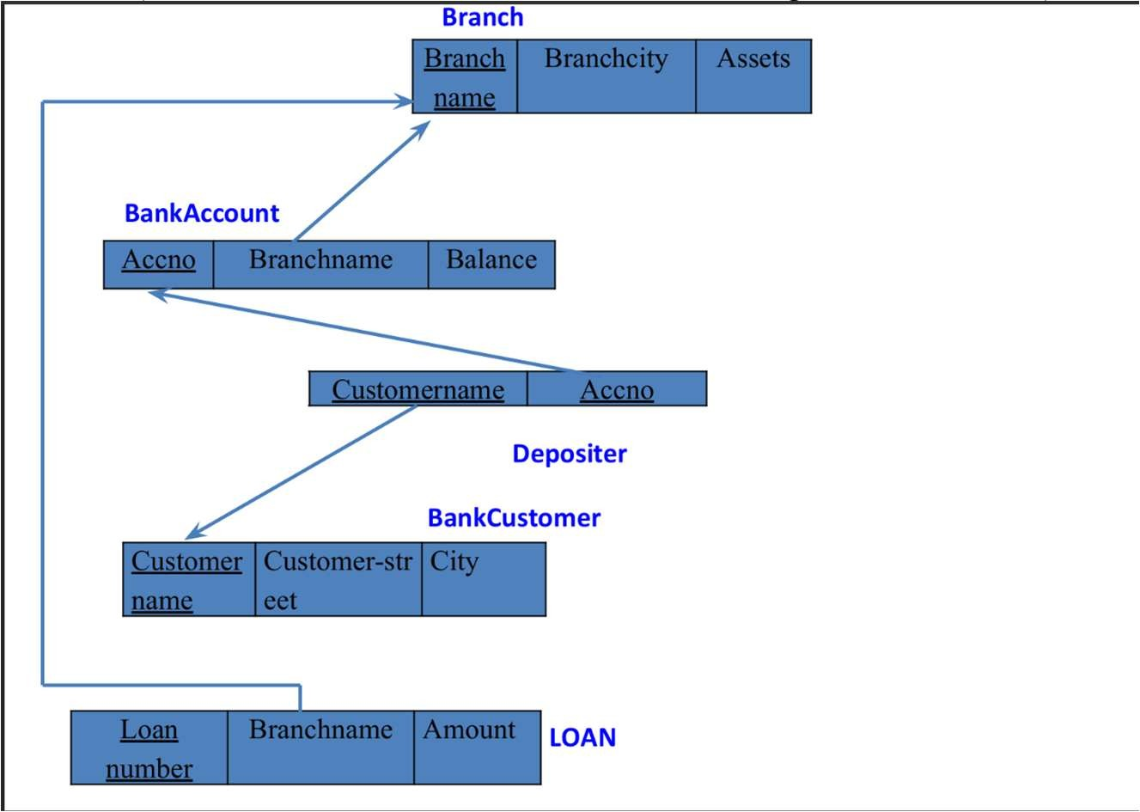

QUERIES AND ITS ANSWERS:

* CREATING DATABASE create database Bank; use Bank;
* Create the above tables by properly specifying the primary keys and the foreign keys.

create table Branch(

BranchName varchar(50) primary key,

BrachCity varchar(50),

Assets real);

create table BankAccount( AccNo int primary key,

BranchName varchar(50),

Balance real,

foreign key(BranchName) references Branch(BranchName)

);

create table Depositer(

CustomerName varchar(50),

AccNo int,

foreign key(AccNo) references BankAccount(AccNo), foreign key(CustomerName) references BankCustomer(CustomerName)

);

create table BankCustomer(

CustomerName varchar(50) primary key,

Customer_street varchar(50) ,

city varchar(50)

);

create table loan( laon_num int primary key,

BranchName varchar(50),

Amount real,

foreign key(BranchName) references Branch(BranchName)

);

structure of tables desc Branch;

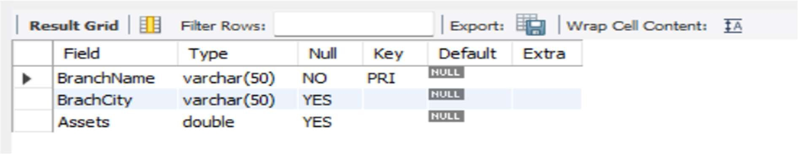

desc BankAccount;

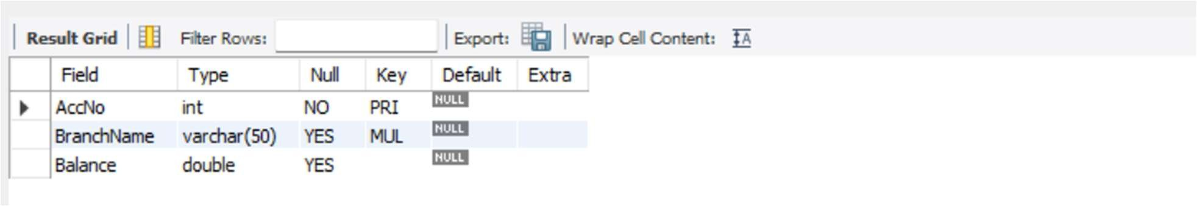

desc BankCustomer;

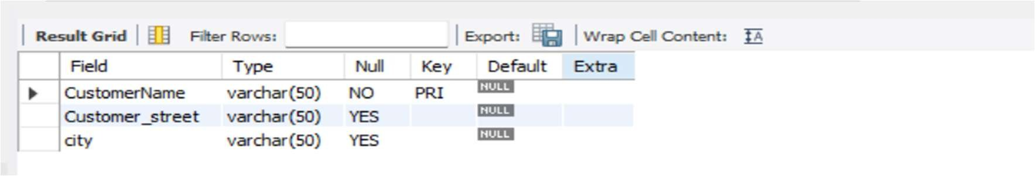

DESC Depositer;

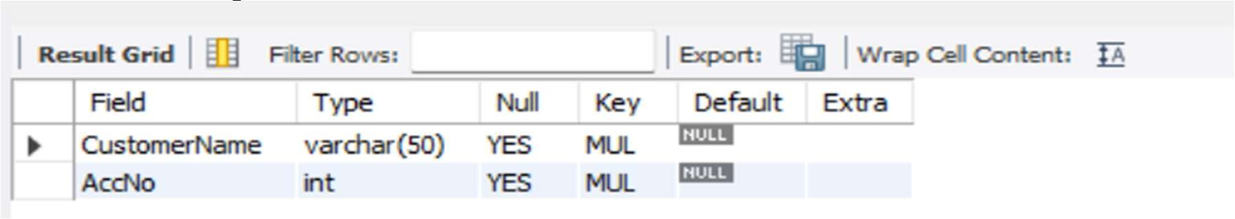

desc loan;

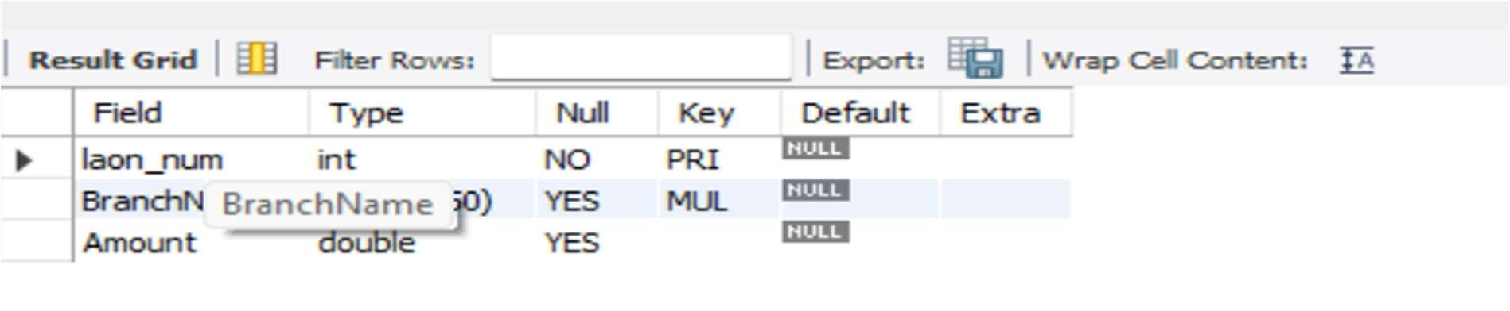

Enter at least five tuples for each relation. inserting values

INSERT INTO Branch VALUES

('SBI_ResidencyRoad', 'Bangalore', 5000000),

('SBI_Indiranagar', 'Bangalore', 3500000),

('SBI_Mysore', 'Mysore', 2000000),

('SBI_Hubli', 'Hubli', 3000000), ('SBI_Dharwad', 'Dharwad', 2500000); select * from Branch;

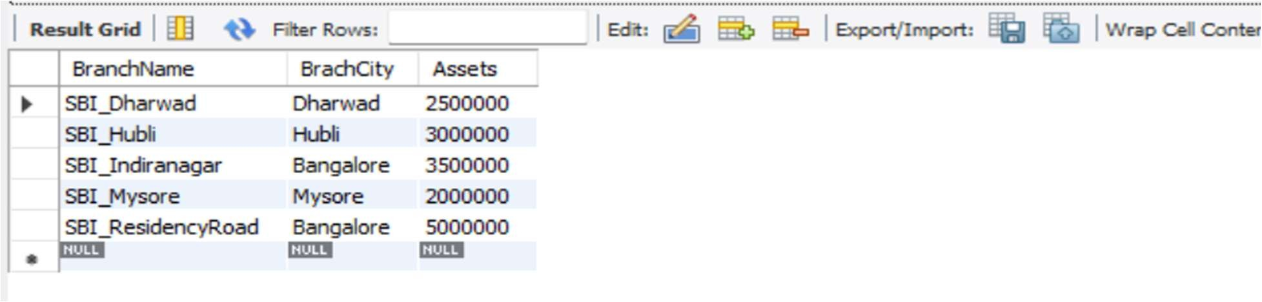

INSERT INTO BankAccount VALUES

(1, 'SBI_ResidencyRoad', 20000),

(2, 'SBI_ResidencyRoad', 50000),

(3, 'SBI_Indiranagar', 15000),

(4,'SBI_Mysore',18000),

(5,'SBI_Mysore',35000),

(6,'SBI_Hubli',20000),

(7,'SBI_Dharwad',10000),

(8, 'SBI_ResidencyRoad', 25000),

(9,'SBI_Indiranagar',23000), (10, 'SBI_ResidencyRoad', 30000); select * from BankAccount;

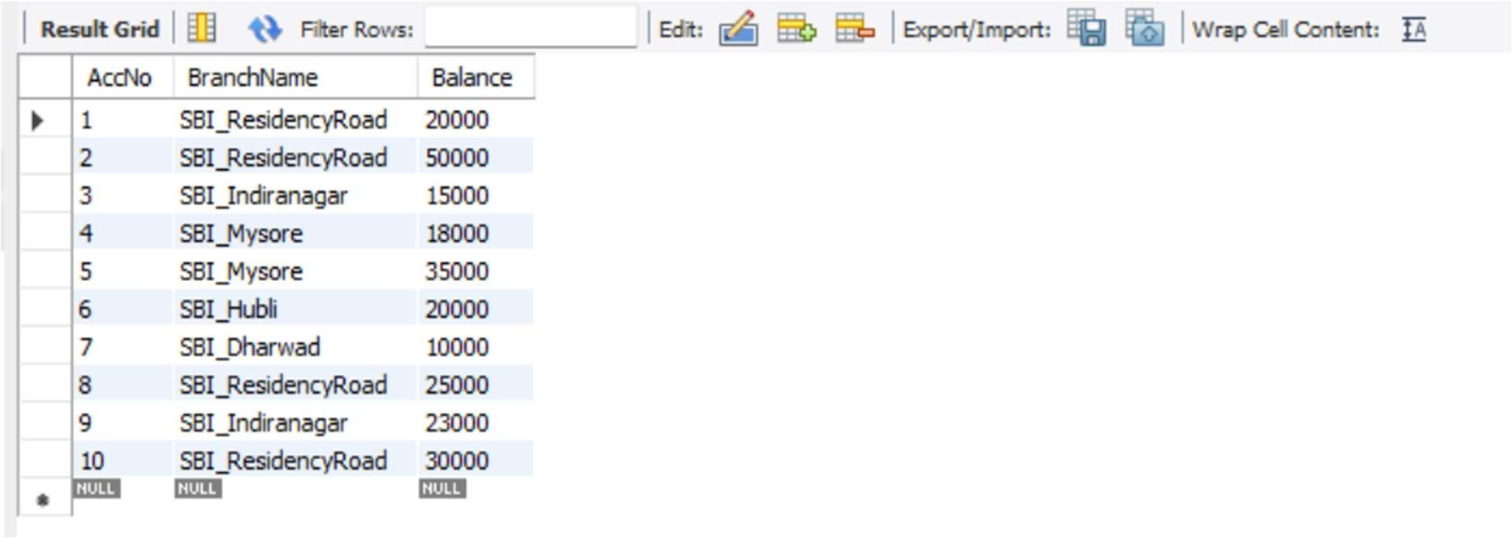

INSERT INTO BankCustomer VALUES

('Dinesh', 'MG Road', 'Bangalore'),

('Avinash', 'Jayanagar', 'Bangalore'),

('Kiran', 'VV Puram', 'Mysore'),

('Priya', 'Hubli Main', 'Hubli'), ('Megha', 'Keshwapur', 'Dharwad'); select * from BankCustomer;

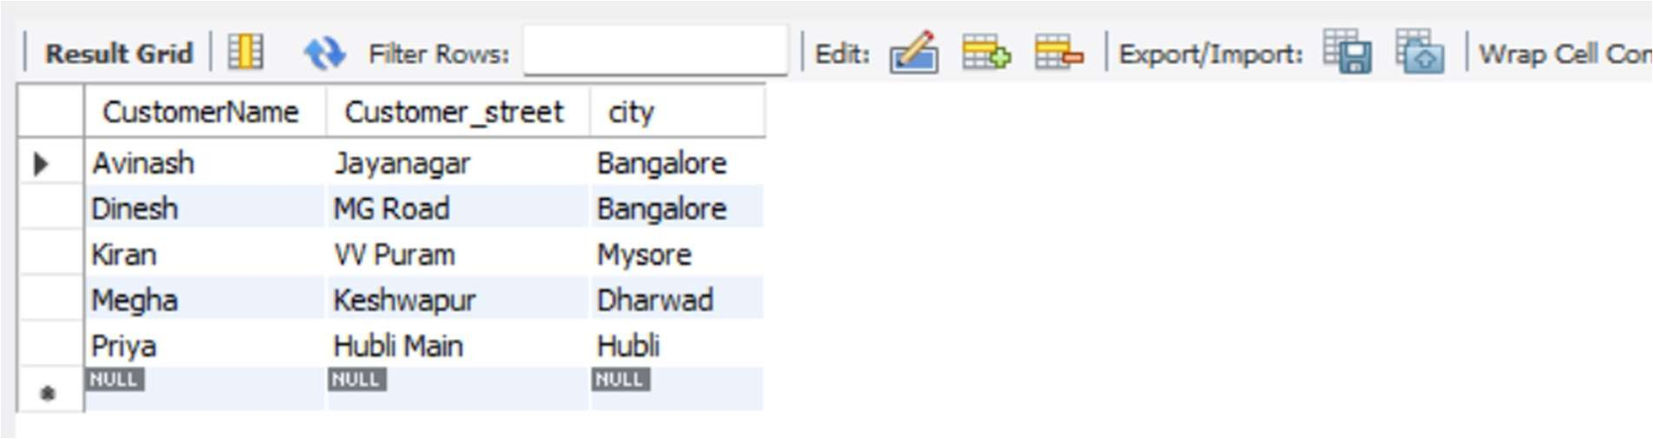

INSERT INTO Depositer VALUES

('Dinesh', 2),

('Avinash', 8),

('Dinesh', 10),

('Kiran', 3), ('Priya', 1); select * from Depositer;

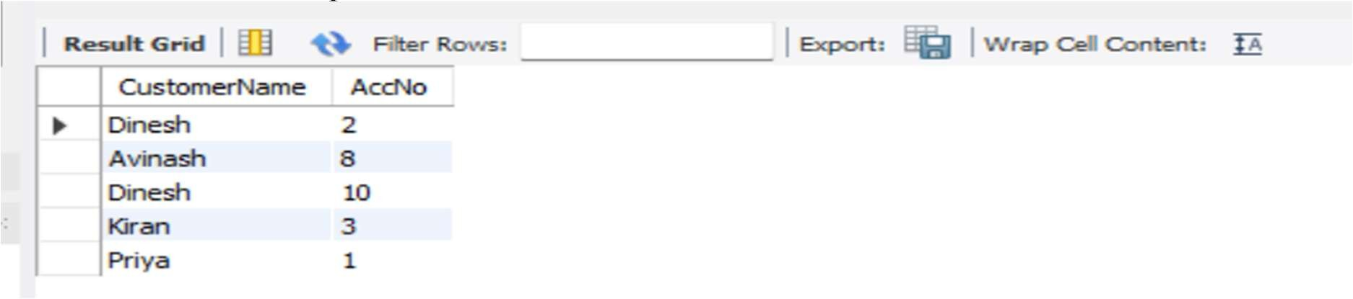

INSERT INTO loan VALUES

(101, 'SBI_ResidencyRoad', 100000),

(102, 'SBI_Indiranagar', 80000),

(103, 'SBI_Mysore', 50000),

(104, 'SBI_Hubli', 70000),

(105, 'SBI_Dharwad', 60000)

;select * from loan;

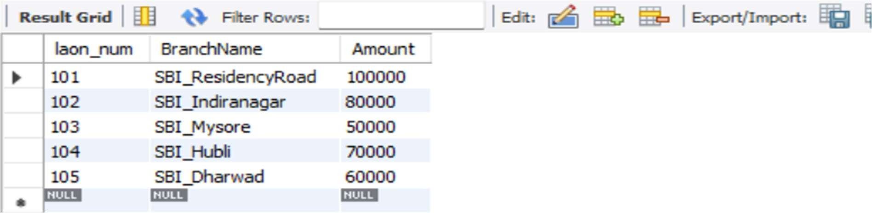

* Display the branch name and assets from all branches in lakhs of rupees and rename the assets column to 'assets in lakhs'.

select BranchName, Assets/100000 as Assets_in_lakhs from Branch;

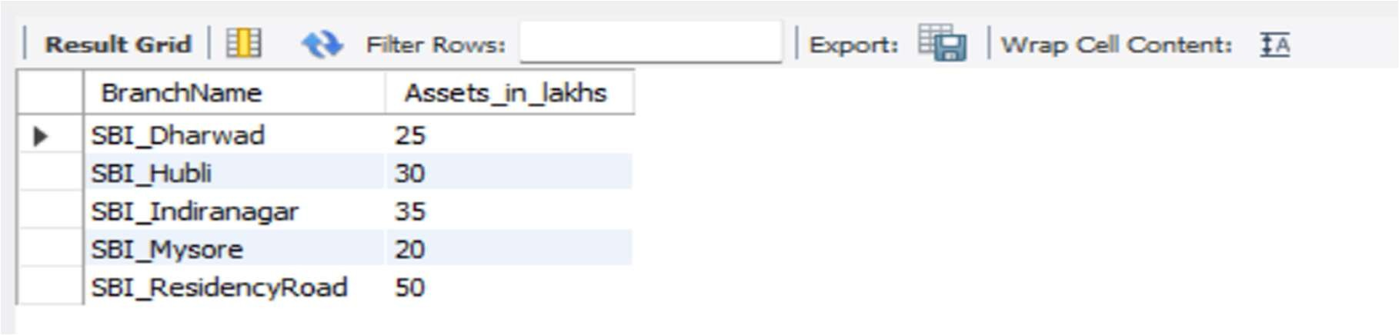

* Find all the customers who have at least two accounts at the same branch (ex.

SBI_ResidencyRoad).

SELECT D.CustomerName, B.BranchName, COUNT(*) AS num_accounts

FROM Depositer D

JOIN BankAccount B

ON D.AccNo = B.AccNo

WHERE B.BranchName = 'SBI_ResidencyRoad'

GROUP BY D.CustomerName

HAVING COUNT(*) >= 2;

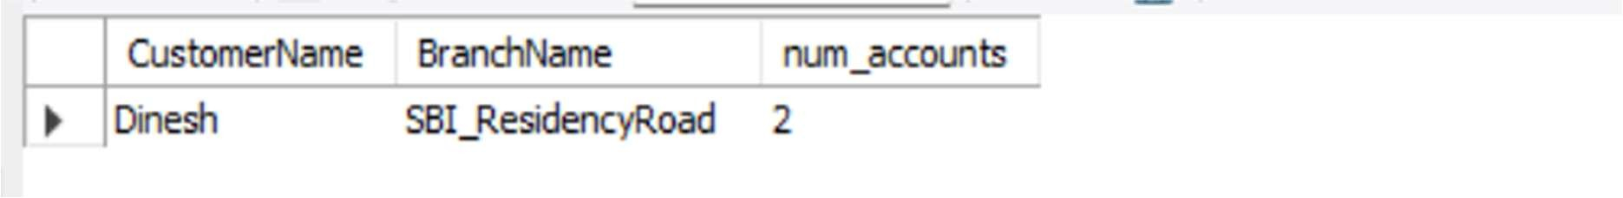

* Create a view which gives each branch the sum of the amount of all the loans at the branch.

CREATE VIEW BranchLoanSummary AS

SELECT BranchName, SUM(Amount) AS total_loan_amount

FROM Loan

GROUP BY BranchName; select * from BranchLoanSummary;

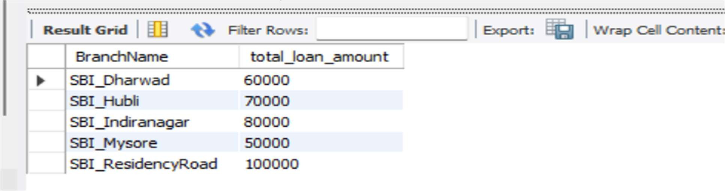

# Experiment 4: More Queries on Bank Database

* Find all the customers who have an account at all the branches located in a specific city

SELECT bc.CustomerName

FROM BankCustomer bc

JOIN Depositer d ON bc.CustomerName = d.CustomerName

JOIN BankAccount ba ON d.AccNo = ba.AccNo

JOIN Branch b ON ba.BranchName = b.BranchName

WHERE b.BrachCity = 'Dharwad'

GROUP BY bc.CustomerName

HAVING COUNT(DISTINCT ba.BranchName) = (

SELECT COUNT(*) FROM Branch WHERE BrachCity = 'Dharwad'

);

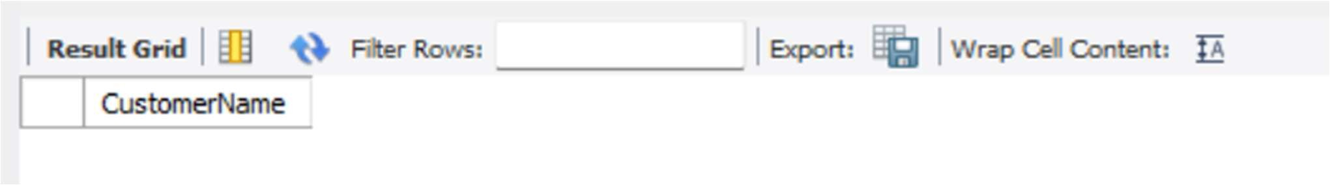

* Find all customers who have a loan at the bank but do not have an account

SELECT bc.CustomerName

FROM BankCustomer bc

LEFT JOIN Depositer d ON bc.CustomerName = d.CustomerName

WHERE d.CustomerName IS NULL;

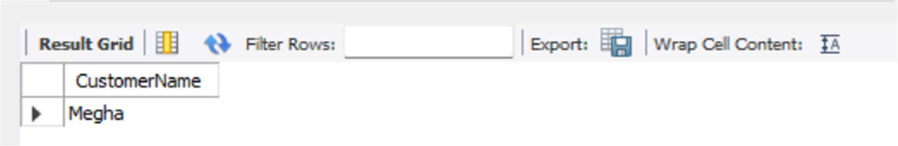

* Find all customers who have both an account and a loan at the Bangalore branch

SELECT DISTINCT bc.CustomerName

FROM BankCustomer bc

JOIN Depositer d ON bc.CustomerName = d.CustomerName

JOIN BankAccount ba ON d.AccNo = ba.AccNo

JOIN Loan l ON ba.BranchName = l.BranchName

JOIN Branch b ON ba.BranchName = b.BranchName

WHERE b.BrachCity = 'Bangalore';

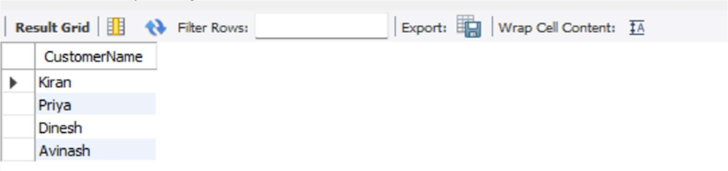

* Find the names of all branches that have greater assets than all branches located in

Bangalore. SELECT BranchName

FROM Branch

WHERE Assets > ALL (

SELECT Assets FROM Branch WHERE BrachCity = 'Bangalore'

);

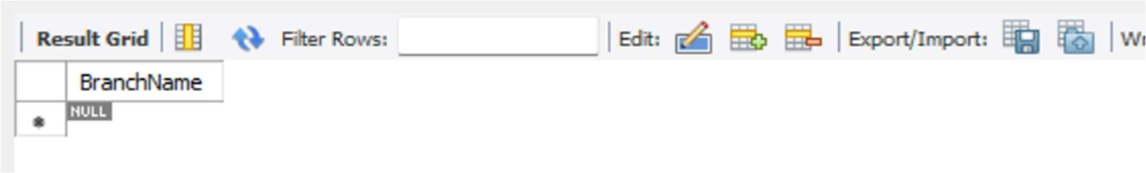

* Demonstrate how you delete all account tuples at every branch located in a specific city

DELETE ba

FROM BankAccount ba

JOIN Branch b ON ba.BranchName = b.BranchName

WHERE b.BrachCity = 'Bombay';



* Update the Balance of all accounts by 5%

UPDATE BankAccount

SET Balance = Balance * 1.05;



select * from BankAccount;

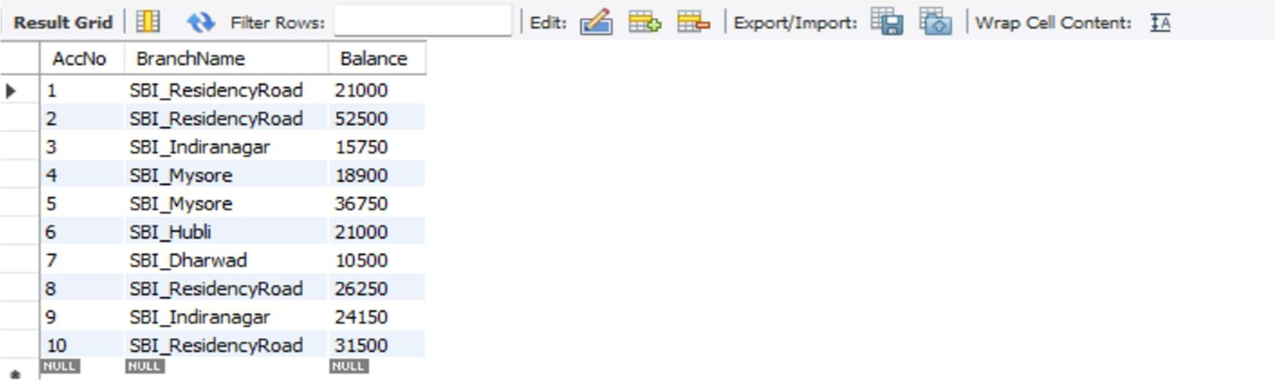

# Experiment 5: Employee Database

Employee Database

The employee database must record each employee’s identifying number, name, manager reference, hire date, salary, and department affiliation while also tracking departmental details, project assignments (including the role an employee plays on a project), and any incentive payments given to employees. Every employee is represented by a unique employee number and has a hire date and salary that must be valid; the manager field is a self-referencing link that must, if present, point to an existing employee and must never create a circular management chain or reference the employee themself. Departments are identified by a unique department number and include a department name and location; every department referenced by an employee or by other structures must exist in the department table, and departments may contain zero or many employees. Projects are recorded with a unique project number, project name and project location; employees may be assigned to multiple projects and each project may have many employees, with each assignment carrying the employee’s job role for that project — duplicate assignments of the same employee to the same project are disallowed. Incentive payments are recorded with the employee reference, the incentive date and the incentive amount; an incentive entry must reference an existing employee and incentive amounts must be non-negative and dated on or after the employee’s hire date. Referential integrity must be enforced so that employee records cannot reference non-existent departments, projects, or managers, and assignment and incentive records cannot exist without corresponding employee, project, or department records as appropriate. Salary, incentive amounts, and any monetary fields must be constrained to valid numeric ranges and hire/ incentive dates must be valid calendar dates (and typically not future-dated unless business rules permit). Deletion and update policies must preserve historical consistency: deleting an employee who appears as a manager, as a project assignee, or in incentive records should be prevented or should be handled via controlled archival, reassignment, or soft-delete flags rather than hard deletion to preserve audit trails; similarly, changing a department or project identifier must either be disallowed if it would orphan historical records or handled by introducing immutable surrogate keys. Business rules include preventing circular manager chains, ensuring an employee’s manager (if specified) cannot be the employee themself, disallowing duplicate project-assignments, requiring that incentive dates fall within the employee’s employment window, and optionally requiring at least one project assignment or at least one incentive record depending on policy for reporting. Implementation should use primary-key and foreign-key constraints for identity and linkage, unique constraints to prevent duplicate assignments, check constraints for monetary and date ranges, and application logic or triggers for complex temporal or graph constraints (like cycle detection in management relationships and enforcing non-overlap or other schedule-related rules if assignments gain temporal attributes later). The system must therefore reliably support queries such as employee reporting lines, department staffing lists, project rosters with job roles, incentive payment histories, salary analyses, and audit reports while maintaining data integrity, preventing inconsistent deletions, and preserving a complete historical record for HR and compliance needs.

ER DIAGRAM:

SCHEMA DIAGRAM:

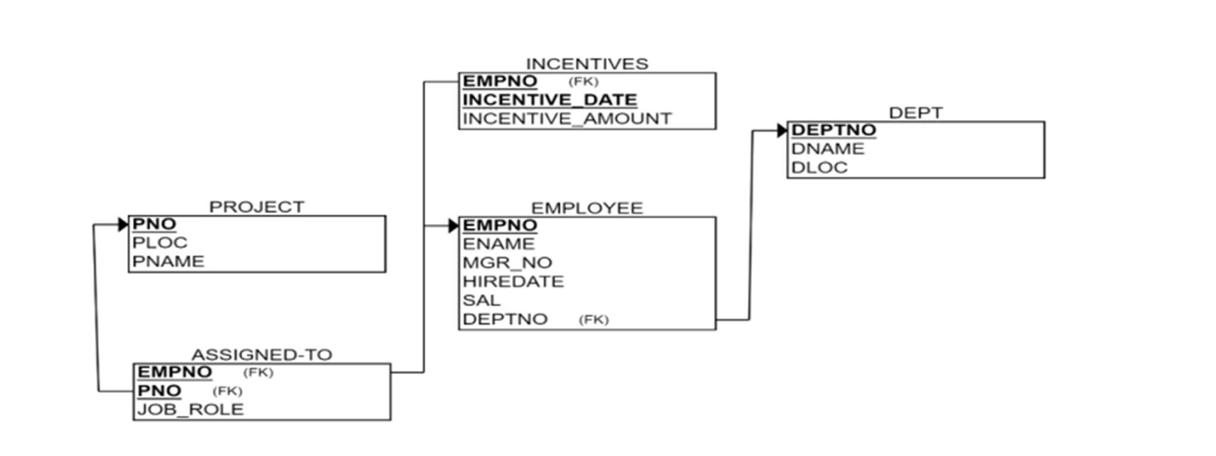 creating database:

create database EMPLOYEES; use EMPLOYEES;

creating tables :

CREATE TABLE DEPT (

DEPTNO INT PRIMARY KEY,

DNAME VARCHAR(50),

DLOC VARCHAR(50)

);

CREATE TABLE EMPLOYEE (

EMPNO INT PRIMARY KEY,

ENAME VARCHAR(50),

MGR_NO INT,

HIREDATE DATE,

SAL DECIMAL(10,2),

DEPTNO INT,

FOREIGN KEY (DEPTNO) REFERENCES DEPT(DEPTNO)

);

CREATE TABLE PROJECT (

PNO INT PRIMARY KEY,

PLOC VARCHAR(50),

PNAME VARCHAR(50)

);

CREATE TABLE ASSIGNED_TO (

EMPNO INT,

PNO INT,

JOB_ROLE VARCHAR(50),

FOREIGN KEY (EMPNO) REFERENCES EMPLOYEE(EMPNO),

FOREIGN KEY (PNO) REFERENCES PROJECT(PNO)

);

CREATE TABLE INCENTIVES (

EMPNO INT,

INCENTIVE_DATE DATE,

INCENTIVE_AMOUNT DECIMAL(10,2),

PRIMARY KEY (INCENTIVE_DATE),

FOREIGN KEY (EMPNO) REFERENCES EMPLOYEE(EMPNO)

);

structure of table:

DESC DEPT;

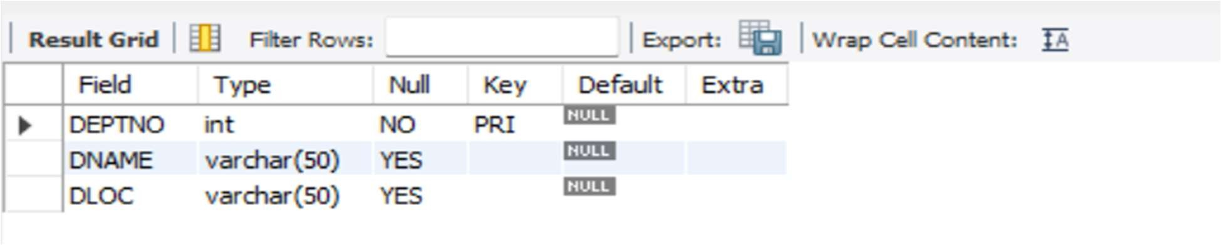

DESC EMPLOYEE;

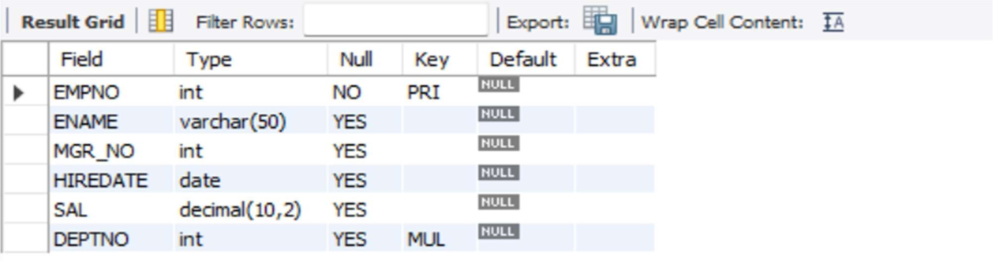

DESC PROJECT;

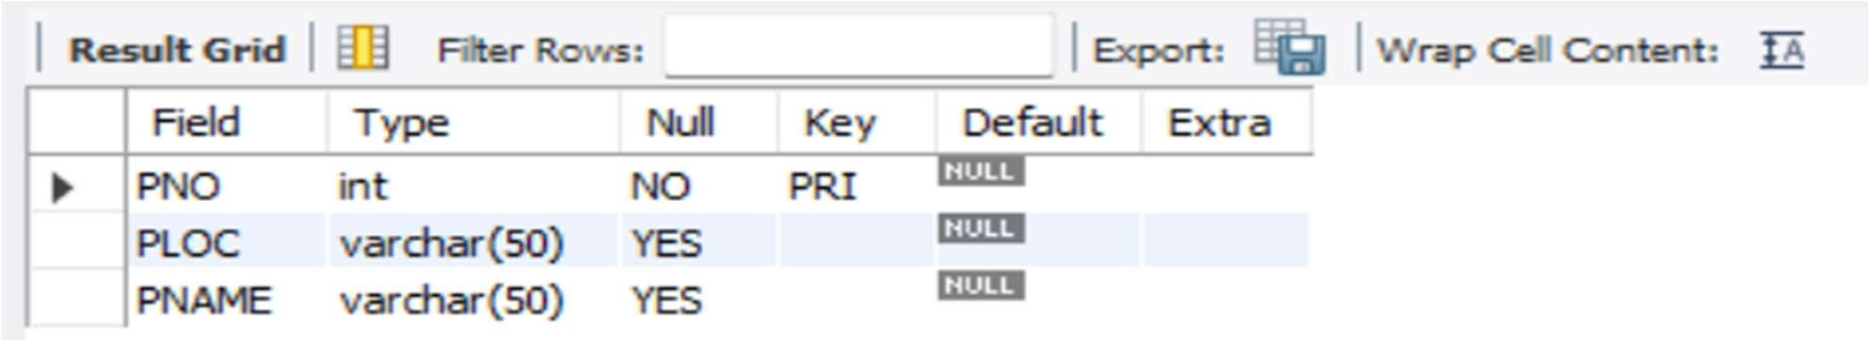

DESC assigned_to;

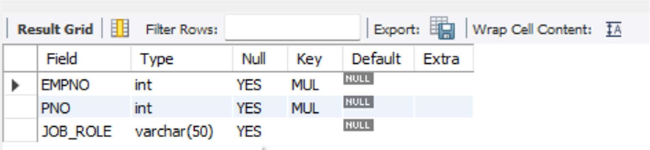

DESC incentives;

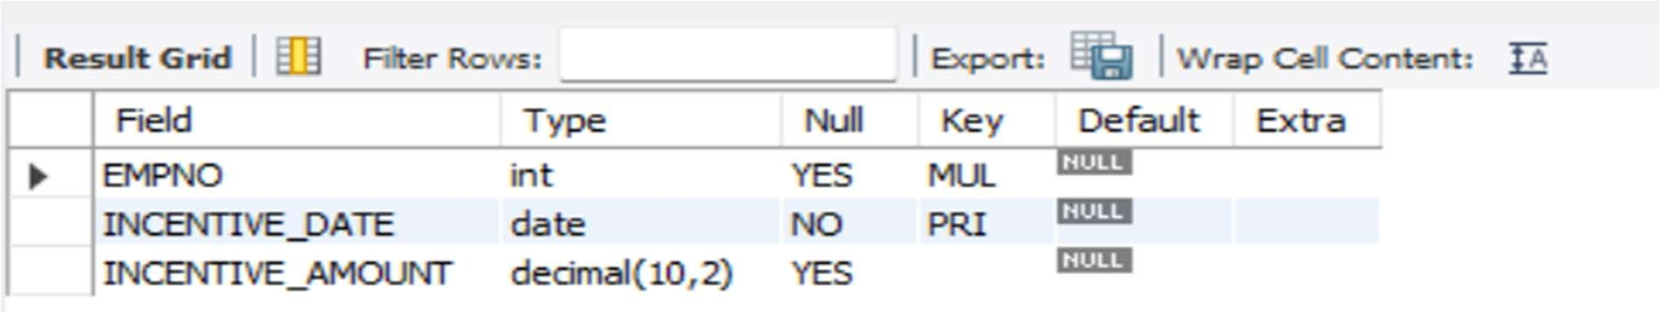

Inserting values into tables:

INSERT INTO DEPT (DEPTNO, DNAME, DLOC) VALUES

(10, 'Operations', 'Bengaluru'),

(20, 'Sales', 'Hyderabad'),

(30, 'Research', 'Mysuru'),

(40, 'HumanResources', 'Chennai'),

(50, 'IT', 'Pune'),

(60, 'Marketing', 'Bengaluru'),

(70, 'Support', 'Hyderabad'); select * from dept;

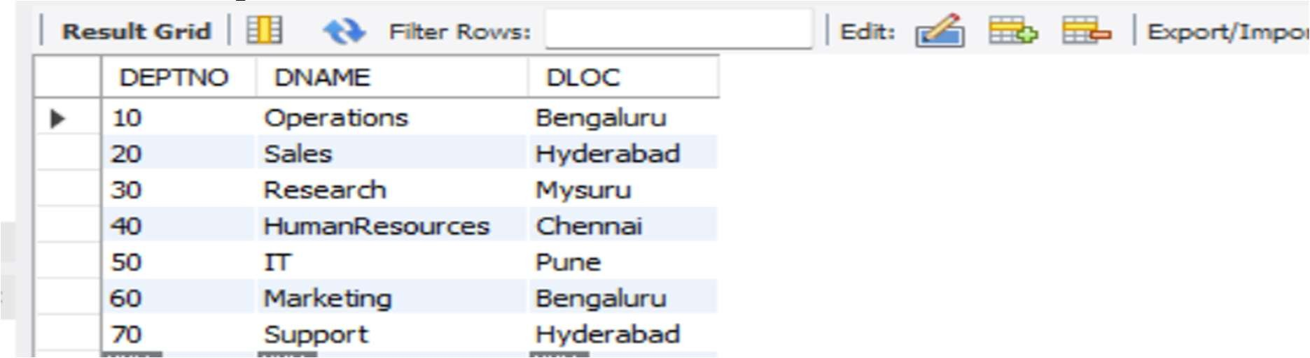

INSERT INTO EMPLOYEE (EMPNO, ENAME, MGR_NO, HIREDATE, SAL, DEPTNO) VALUES

(1001, 'Ravi Kumar', NULL, '2022-01-15', 60000.00, 10),

(1002, 'Anita Singh', 1001, '2022-03-10', 55000.00, 20),

(1003, 'Suresh Patil', 1001, '2022-05-05', 50000.00, 10),

(1004, 'Priya Menon', 1002, '2022-07-20', 65000.00, 30),

(1005, 'Amit Sharma', 1002, '2022-09-01', 70000.00, 50),

(1006, 'Sunita Rao', 1001, '2023-01-10', 52000.00, 60),

(1007, 'Deepak Verma', 1003, '2023-02-05', 48000.00, 70); select * from employee;

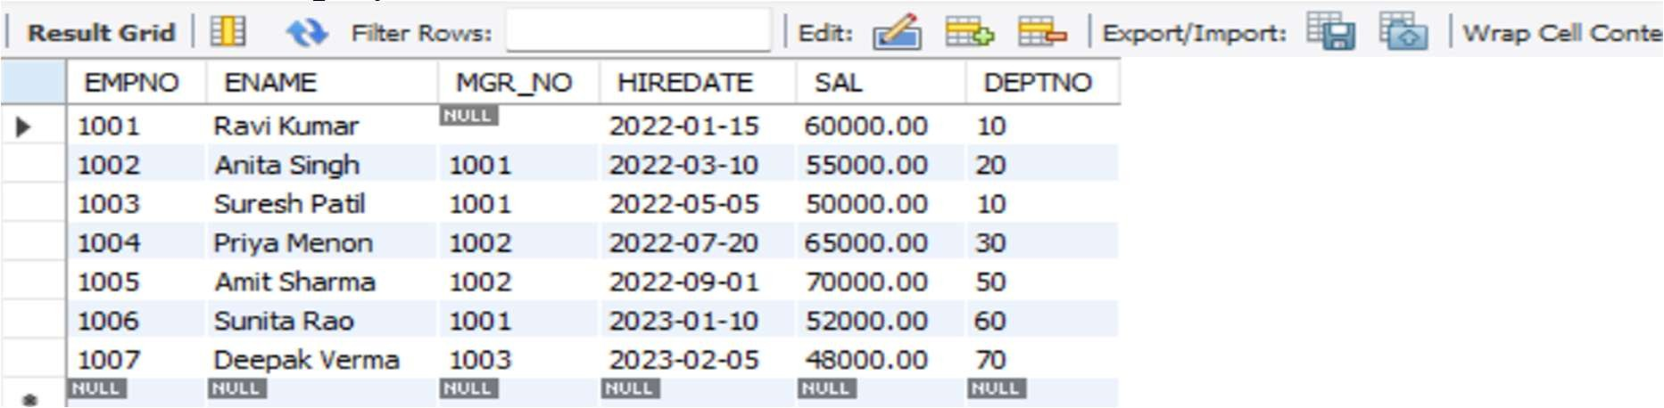

INSERT INTO PROJECT (PNO, PLOC, PNAME) VALUES

(101, 'Bengaluru', 'CloudMigration'),

(102, 'Hyderabad', 'MobileAppDev'),

(103, 'Mysuru', 'AIResearch'),

(104, 'Chennai', 'HRSystemRevamp'),

(105, 'Pune', 'NetworkUpgrade'),

(106, 'Bengaluru', 'ECommercePlatform'),

(107, 'Hyderabad', 'CustomerSupportTool');

select * from project;

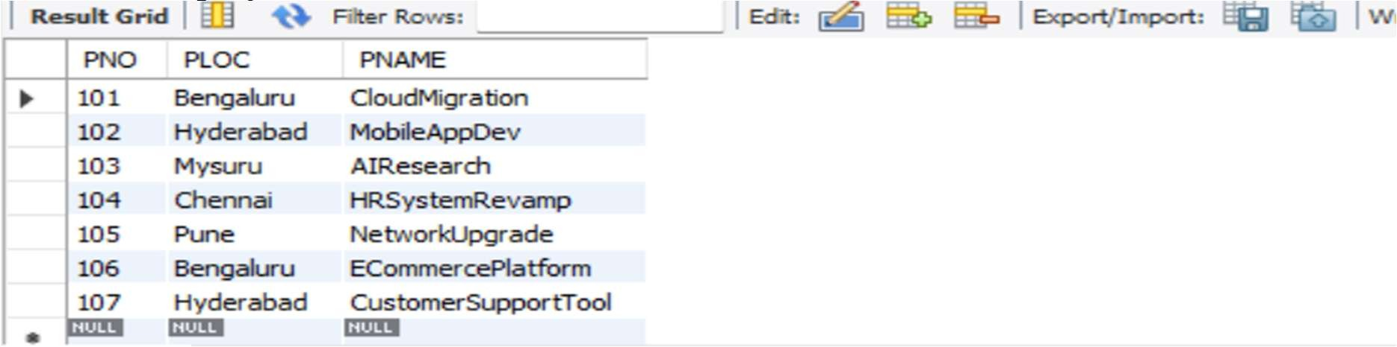

INSERT INTO ASSIGNED_TO (EMPNO, PNO, JOB_ROLE) VALUES

(1001, 101, 'Lead Architect'),

(1002, 102, 'Project Manager'),

(1003, 101, 'Developer'),

(1004, 103, 'Data Scientist'),

(1005, 105, 'Network Engineer'),

(1006, 106, 'E-Commerce Engineer'), (1007, 107, 'Support Engineer'); select * from assigned_to;

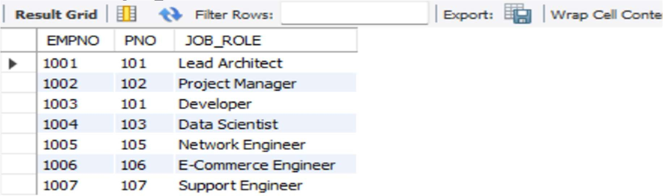

INSERT INTO INCENTIVES (EMPNO, INCENTIVE_DATE, INCENTIVE_AMOUNT) VALUES

(1001, '2022-12-31', 5000.00),

(1002, '2023-01-15', 4500.00),

(1003, '2023-02-28', 4000.00),

(1004, '2023-03-30', 5500.00), (1006, '2023-04-15', 3000.00); select * from incentives;

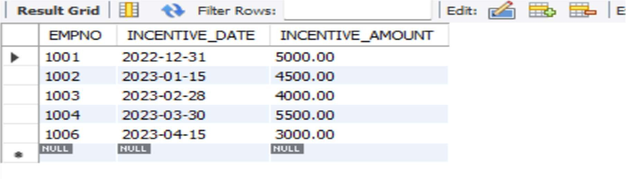

Queries and solutions

* Retrieve the employee numbers of all employees who work on project located in Bengaluru, Hyderabad, or Mysuru

select a.EMPNO from assigned_to a join project p

on a.PNO=p.PNO

where PLOC in('Bengalure','Hyderabad', 'Mysuru');

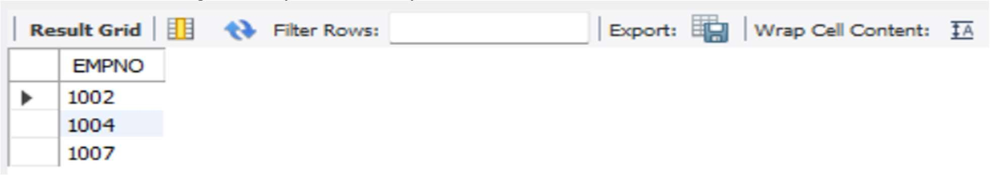

* Get Employee ID’s of those employees who didn’t receive incentives select e.EMPNO from employee e

left join incentives i

on i.EMPNO=e.EMPNO where i.EMPNO is NULL;

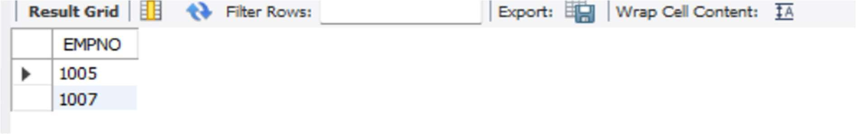

* Write a SQL query to find the employees name, number, dept, job_role, department location and project location who are working for a project location same as his/her department location.

select E.EMPNO,E.ENAME,D.DEPTNO,A.JOB_ROLE,D.DLOC,P.PLOC FROM EMPLOYEE E

JOIN assigned_to A on E.EMPNO=A.EMPNO

JOIN DEPT D ON E.DEPTNO=D.DEPTNO

JOIN PROJECT P ON P.PNO=A.PNO WHERE D.DLOC=P.PLOC;

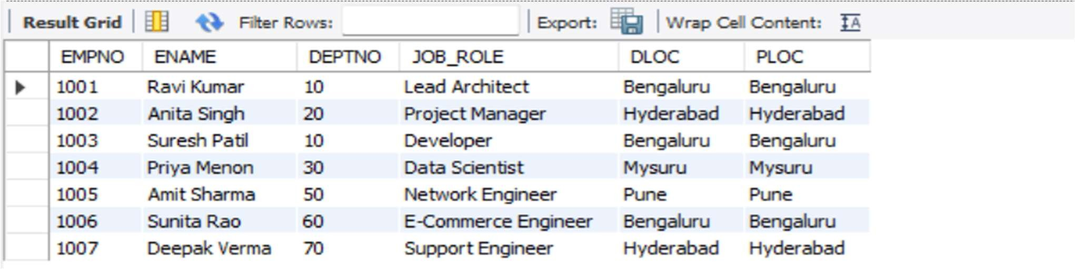

# Experiment 6: More Queries on Employee Database

Queries and solutions

● List the name of the managers with the maximum employees

SELECT m.ENAME

FROM EMPLOYEE m

LEFT JOIN EMPLOYEE e ON m.EMPNO = e.MGR_NO

GROUP BY m.EMPNO, m.ENAME

HAVING COUNT(e.EMPNO) = (

SELECT MAX(cnt)

FROM (

SELECT COUNT(e2.EMPNO) AS cnt

FROM EMPLOYEE m2

LEFT JOIN EMPLOYEE e2 ON m2.EMPNO = e2.MGR_NO

GROUP BY m2.EMPNO

) t

);

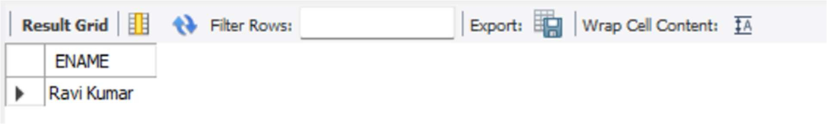

* Display those managers name whose salary is more than average salary of his employee.

SELECT m.ENAME

FROM EMPLOYEE m

WHERE m.SAL > (

SELECT AVG(e.SAL)

FROM EMPLOYEE e

WHERE e.MGR_NO = m.EMPNO

);

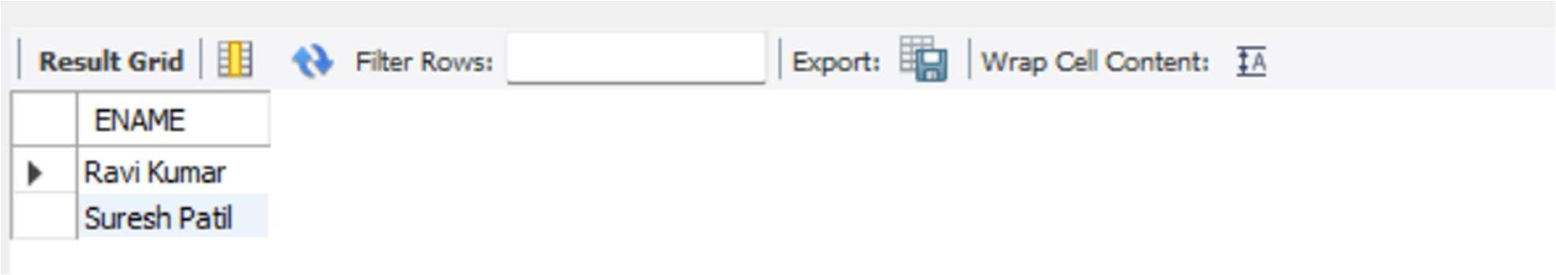

* Find the name of the second top level managers of each department

SELECT DISTINCT e.ENAME, e.DEPTNO

FROM EMPLOYEE e

WHERE e.MGR_NO IN (

SELECT EMPNO

FROM EMPLOYEE

WHERE MGR_NO IS NULL

);

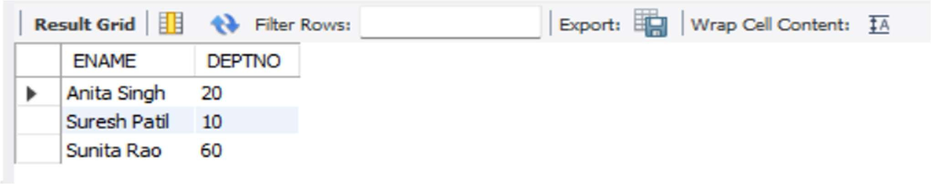

* Find the employee details who got second maximum incentive in January 2023.

SELECT *

FROM EMPLOYEE

WHERE EMPNO = (

SELECT EMPNO

FROM INCENTIVES

WHERE YEAR(INCENTIVE_DATE) = 2023 and month(INCENTIVE_DATE)=1

AND INCENTIVE_AMOUNT = (

SELECT MAX(INCENTIVE_AMOUNT)

FROM INCENTIVES

WHERE YEAR(INCENTIVE_DATE) = 2023 and month(INCENTIVE_DATE)=1

AND INCENTIVE_AMOUNT < (

SELECT MAX(INCENTIVE_AMOUNT)

FROM INCENTIVES

WHERE YEAR(INCENTIVE_DATE) = 2023 and month(INCENTIVE_DATE)=1

)

)

);

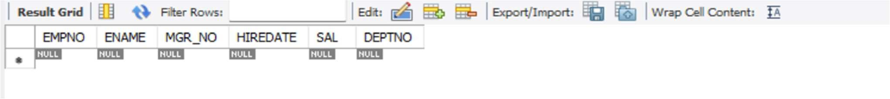

● Display those employees who are working in the same department where his manager is working. SELECT e.ENAME

FROM EMPLOYEE e

JOIN EMPLOYEE m ON e.MGR_NO = m.EMPNO

WHERE e.DEPTNO = m.DEPTNO;

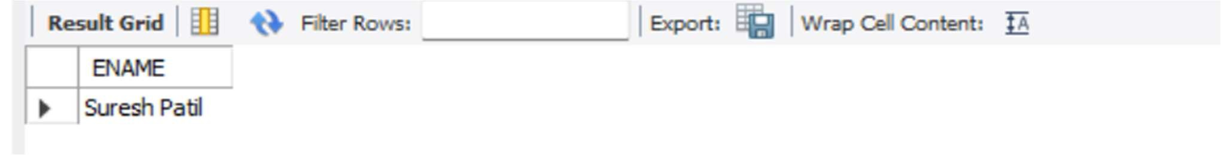

# Experiment 7: Supplier Database

Supplier Database

The supplier database must store information about suppliers, the parts they provide, and the prices at which each part is offered so that purchasing, analysis, and reporting can be done accurately. Each supplier is uniquely identified by a supplier ID and is recorded with a name and the city in which the supplier is located; each part is uniquely identified by a part ID and includes a part name and a color. The system must maintain a catalog that links suppliers to the parts they supply and records the cost at which a given supplier sells a given part. Every catalog entry must reference an existing supplier and an existing part, and there must be no duplicate entries for the same combination of supplier and part, so that at most one current price record exists per supplier–part pair. Costs must be valid numeric values and strictly non-negative, and business rules may specify upper limits or currency formats that must be enforced consistently. The data model must support the possibility that a supplier can provide many different parts, that a part can be supplied by many different suppliers, and that some suppliers or parts may temporarily have no catalog entries if they are inactive or not currently traded. Referential integrity must be enforced so that a supplier or part cannot be deleted while still referenced in the catalog unless such deletion is handled by controlled archival or cascade rules that preserve historical price information; in general, historical catalog data should not be lost, as it may be required for audits or trend analysis. The system should allow queries such as “find all suppliers for a given part,” “list all parts provided by a given supplier,” “retrieve the cheapest supplier for each part,” and “analyze supplier coverage by city,” and must therefore guarantee that identifiers are unique, relationships between suppliers, parts, and catalog entries are consistent, and price information is accurate and reliably maintained over time.

ER DIAGRAM

SCHEMA DIAGRAM

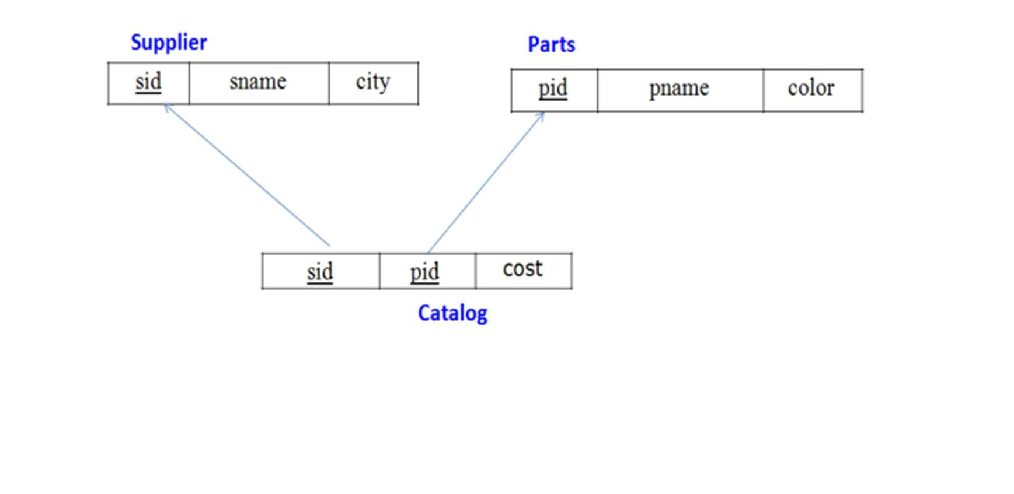

QUERIES AND SOLUTION

creating database create database supplier; use supplier;

creating tables

CREATE TABLE Supplier ( sid INT PRIMARY KEY, sname VARCHAR(50),

city VARCHAR(50)

);

CREATE TABLE Parts ( pid INT PRIMARY KEY, pname VARCHAR(50),

color VARCHAR(20)

);

CREATE TABLE Catalog ( sid INT,

pid INT,

cost DECIMAL(10,2),

PRIMARY KEY (sid, pid),

FOREIGN KEY (sid) REFERENCES Supplier(sid),

FOREIGN KEY (pid) REFERENCES Parts(pid)

);

structure of table desc supplier;

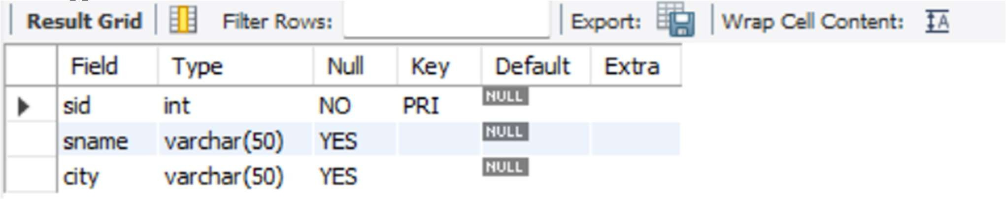

desc parts;

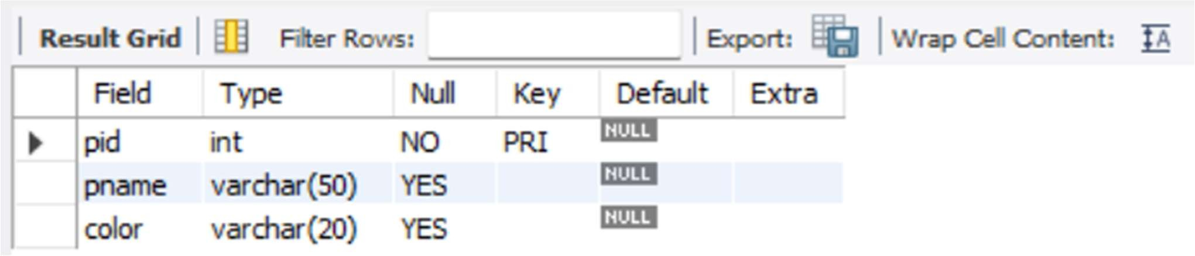

desc catalog;

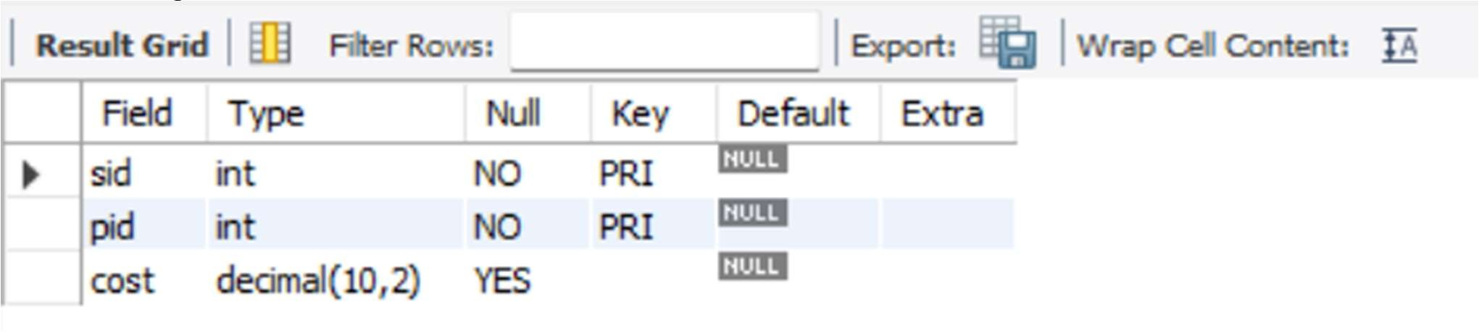

INSERTING VALUES INTO TABLES

INSERT INTO Supplier (sid, sname, city) VALUES

(1, 'Acme Widget Suppliers','Bengaluru'),

(2, 'Global Parts Ltd','Mumbai'),

(3, 'Sunrise Traders','Chennai'),

(4, 'NorthStar Components','Hyderabad'),

(5, 'RapidSupply Co', 'Pune'); select * from supplier;

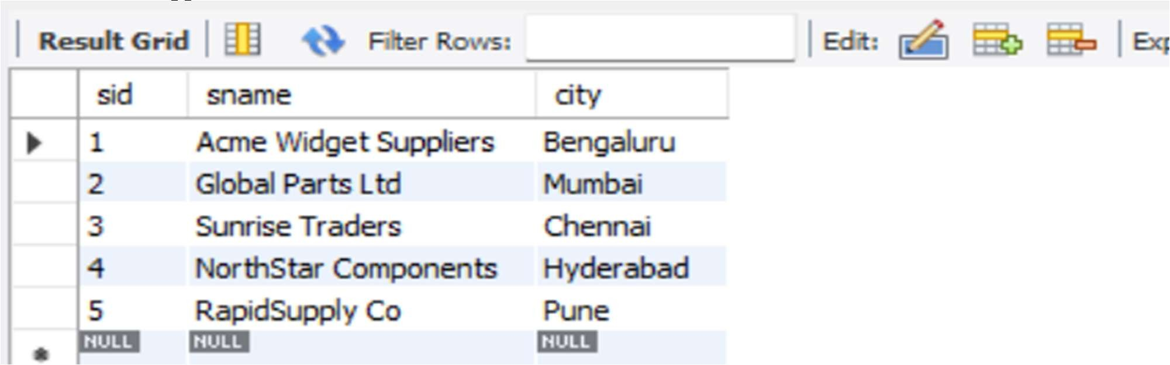

INSERT INTO Parts (pid, pname, color) VALUES

(101, 'Bolt', 'Red'),

(102, 'Nut', 'Blue'),

(103, 'Screw', 'Red'),

(104, 'Washer', 'Green'), (105, 'Gear', 'Blue'); select * from Parts;

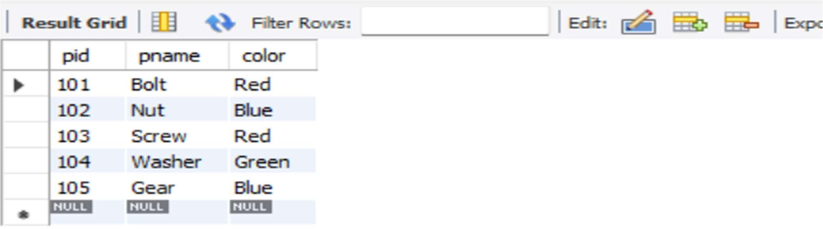

INSERT INTO Catalog (sid, pid, cost) VALUES

(1, 101, 12.50),

(1, 102, 10.00),

(2, 101, 11.00),

(2, 103, 9.50),

(3, 104, 8.00),

(3, 103, 9.00),

(4, 105, 15.75),

(4, 101, 13.25),

(5, 102, 10.50), (5, 105, 14.00); select * from catalog;

## queries

* Find the pnames of parts for which there is some supplier. select distinct p.pname from parts p join Catalog c on c.pid=p.pid;

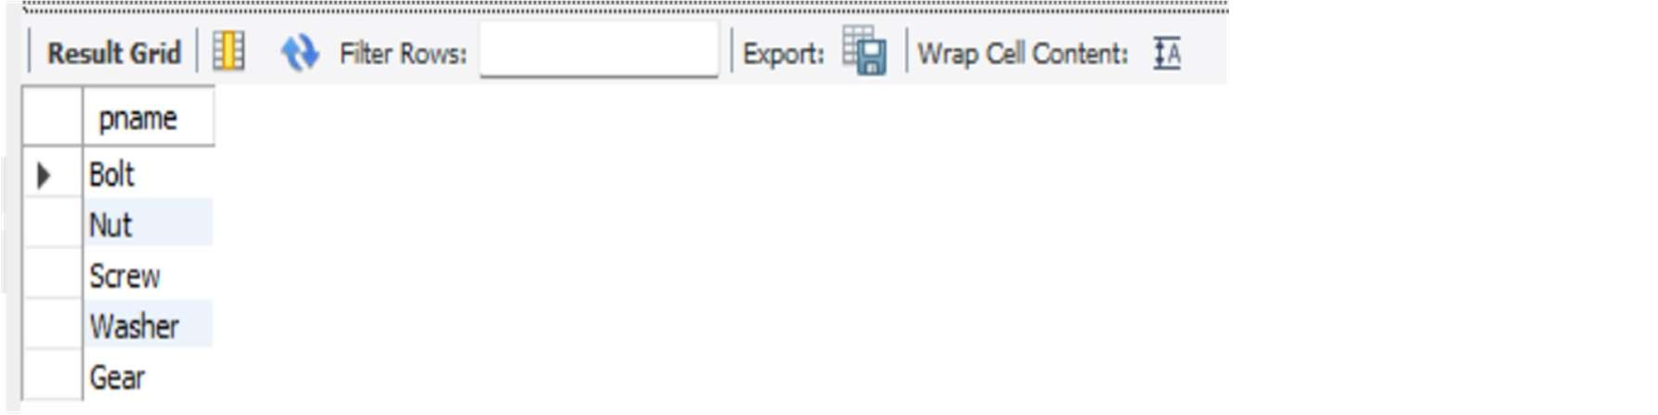

* Find the snames of suppliers who supply every part.

SELECT s.sname FROM Supplier s

JOIN Catalog c

ON s.sid = c.sid

GROUP BY s.sname

HAVING COUNT(DISTINCT c.pid) = (

SELECT COUNT(*)

FROM Parts

);

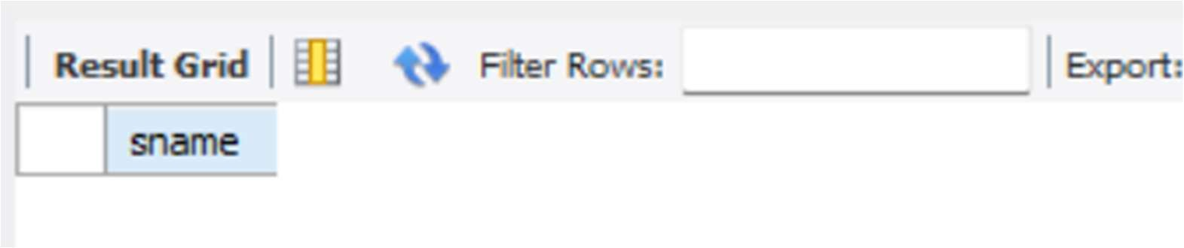

# Experiment 8: More Queries On Supplier Database

## queries and solution

* Find the snames of suppliers who supply every red part.

SELECT s.sname FROM Supplier s

JOIN Catalog c ON s.sid = c.sid

JOIN Parts p ON c.pid = p.pid AND p.color = 'Red'

GROUP BY s.sname

HAVING COUNT(DISTINCT p.pid) = (

SELECT COUNT(*)

FROM Parts

WHERE color = 'Red'

);

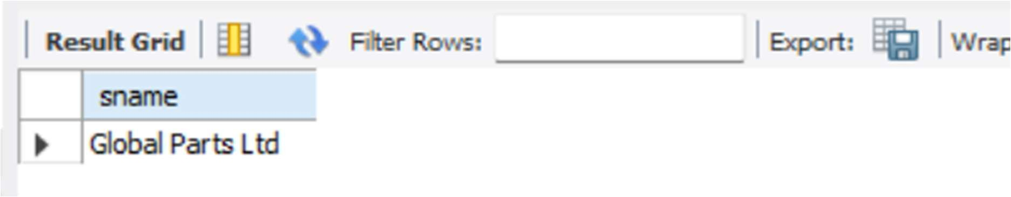

* Find the pnames of parts supplied by Acme Widget Suppliers and by no one else

SELECT p.pname

FROM Parts p

JOIN Catalog c ON p.pid = c.pid

JOIN Supplier s ON c.sid = s.sid

WHERE s.sname = 'Acme Widget Suppliers'

AND NOT EXISTS (

SELECT 1

FROM Catalog c2

JOIN Supplier s2 ON c2.sid = s2.sid

WHERE c2.pid = p.pid

AND s2.sname <> 'Acme Widget Suppliers'

);

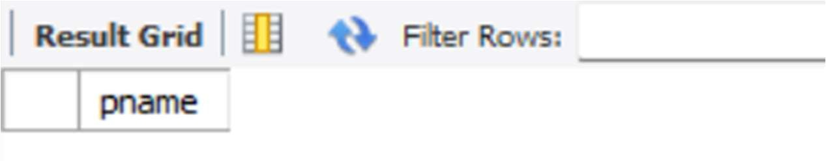

* Find the sids of suppliers who charge more for some part than the average cost of that part (averaged over all the suppliers who supply that part).

SELECT DISTINCT c.sid

FROM Catalog c

WHERE c.cost > (

SELECT AVG(c2.cost)

FROM Catalog c2

WHERE c2.pid = c.pid);

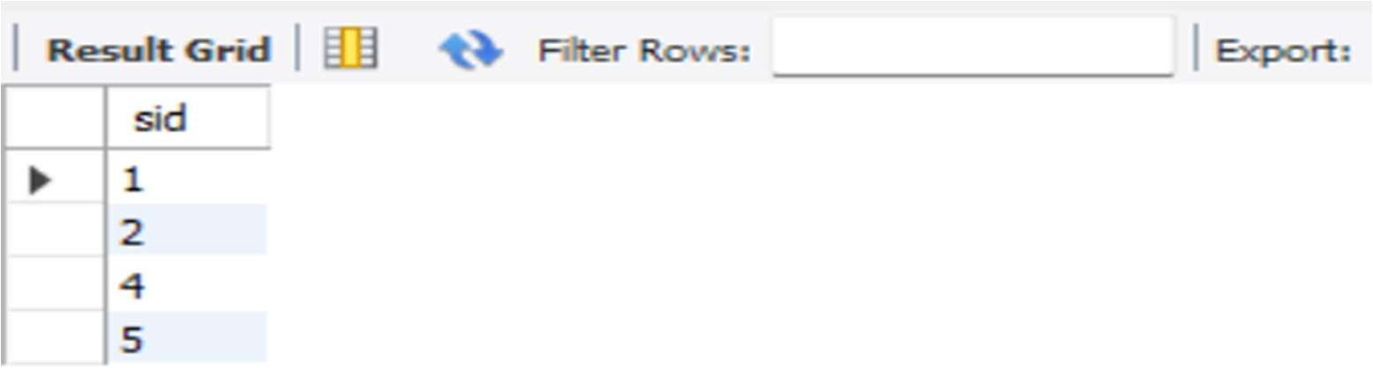

* For each part, find the sname of the supplier who charges the most for that part.

SELECT P.pname,

S.sname

FROM Parts P

JOIN Catalog C ON P.pid = C.pid

JOIN Supplier S ON C.sid = S.sid

WHERE C.cost = (

SELECT MAX(C2.cost)

FROM Catalog C2

WHERE C2.pid = P.pid

);

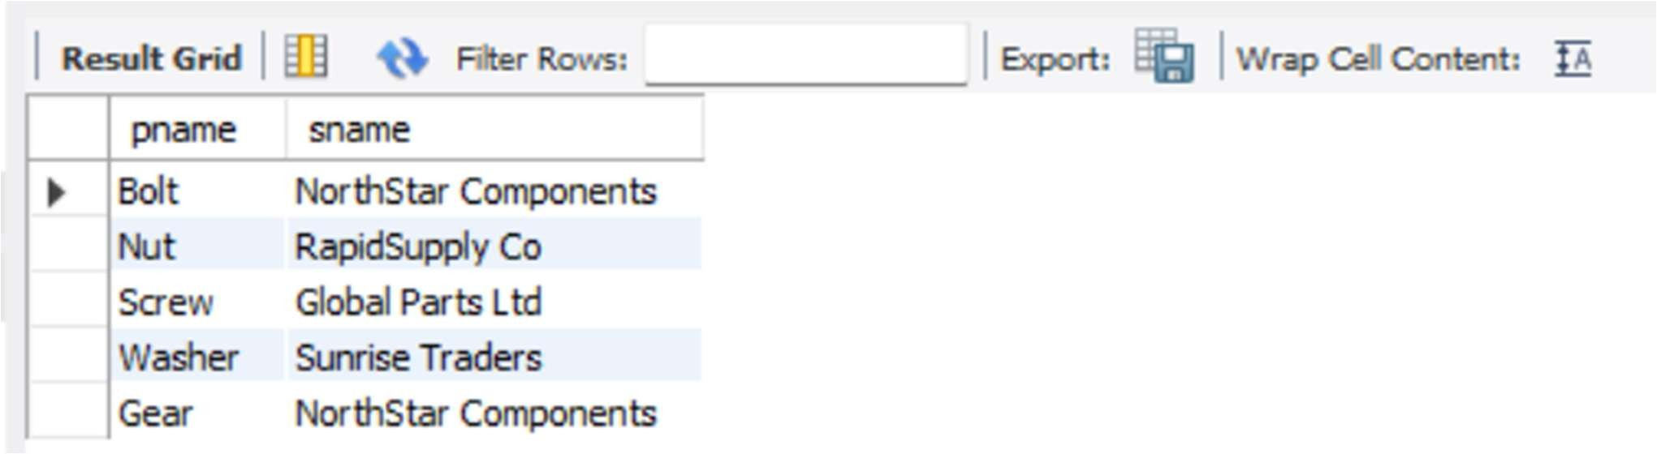

# Experiment 9: NOSQL Installation in Cloud

MONGODB INSTALLATION STEPS (WINDOWS)

1. Open a web browser

Go to the official MongoDB website and download MongoDB Community Server.

1. Select download options Choose:

* 1. Version: Latest

○ Operating System: Windows

○ Package: MSI Click on Download.

1. Run the installer

Open the downloaded .msi file and click Next.

1. Accept license agreement

Accept the license terms and click Next.

1. Choose setup type

Select Complete installation and click Next.

1. Install MongoDB as a service

* 1. Check Install MongoDB as a Service

○ Service name: MongoDB

○ Run service as Network Service user Click Next.

1. Install MongoDB Compass

Check Install MongoDB Compass (GUI tool).

Click Next and then Install.

1. Finish installation

Wait for installation to complete and click Finish.

Verify MongoDB installation Open Command Prompt and type:

mongod --version

1. If version is displayed, MongoDB is installed successfully.

1. Start MongoDB service (if needed)

Open Command Prompt as Administrator and run: net start MongoDB

Experiment 10: NoSQL Student Database

creating database stud ; use stud; create a new collection:

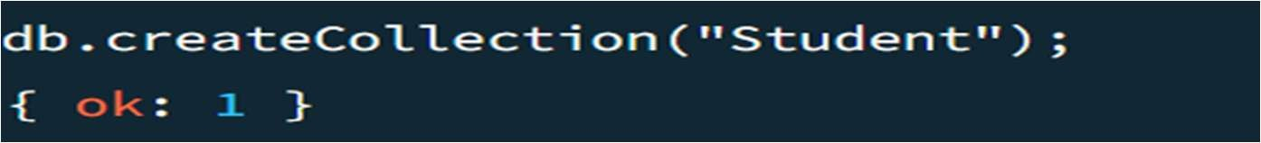

inserting values:

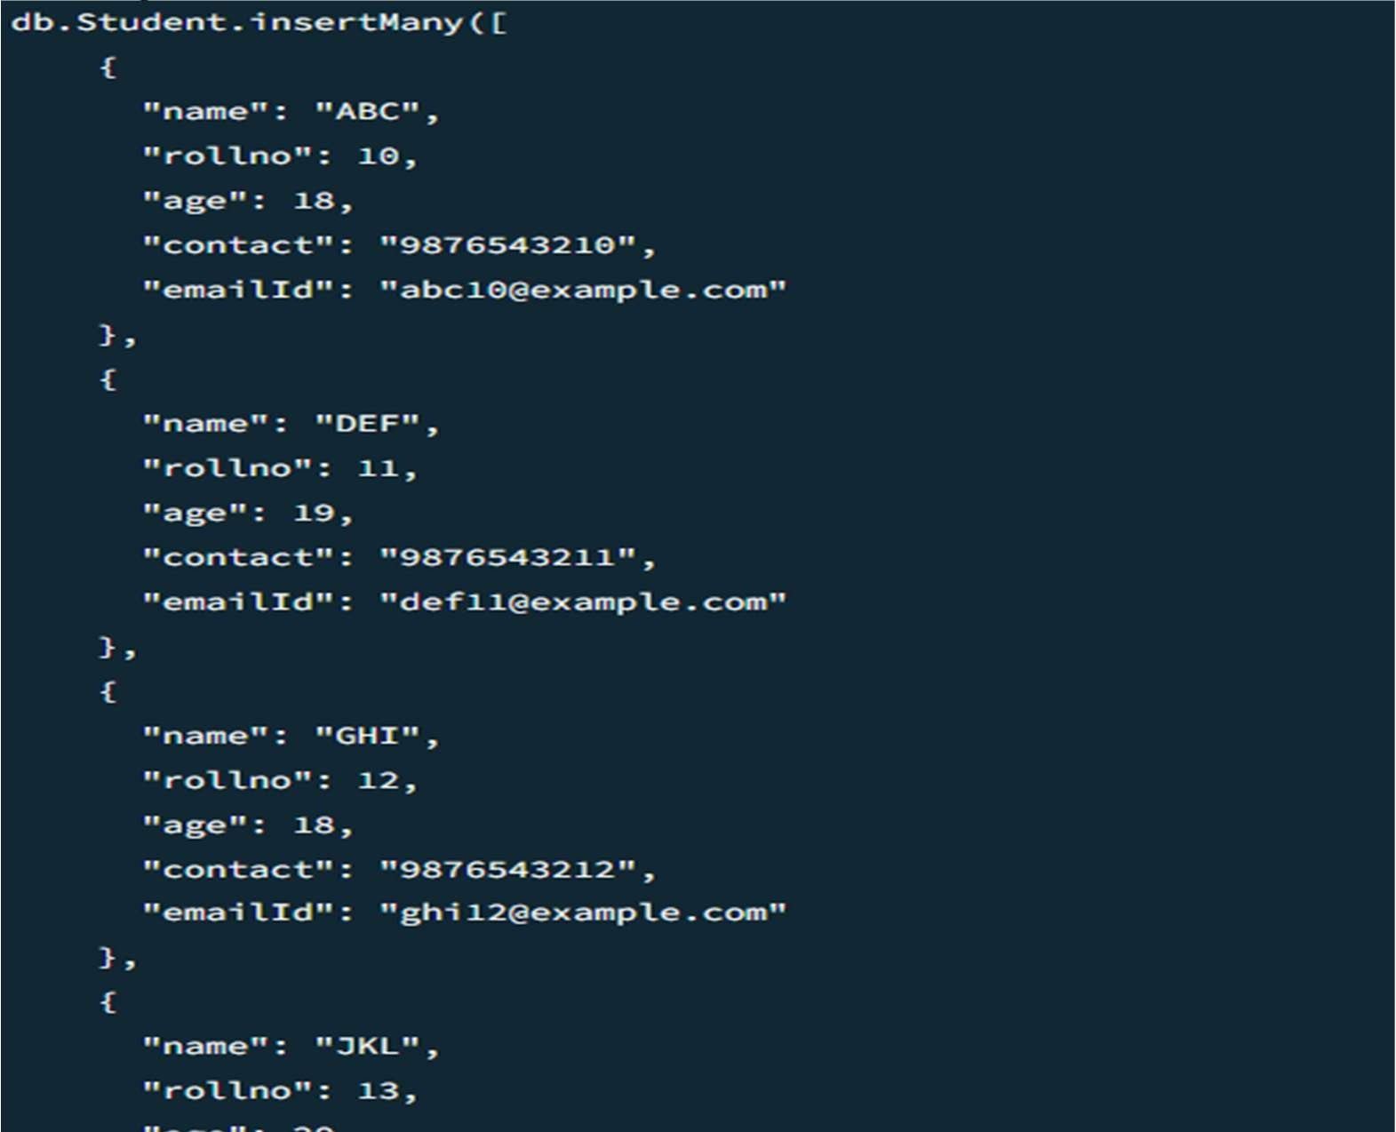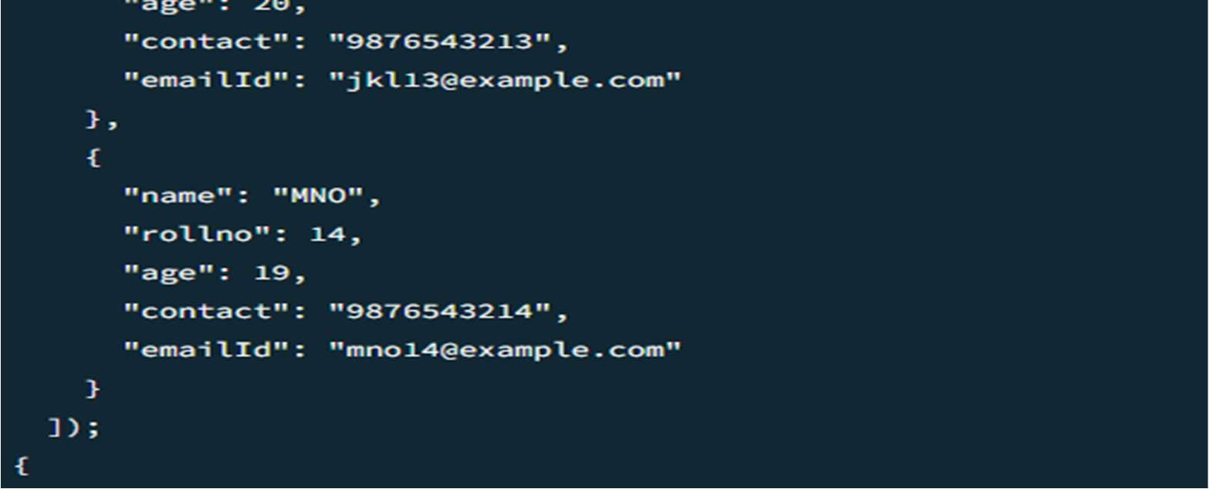

ddd

output:

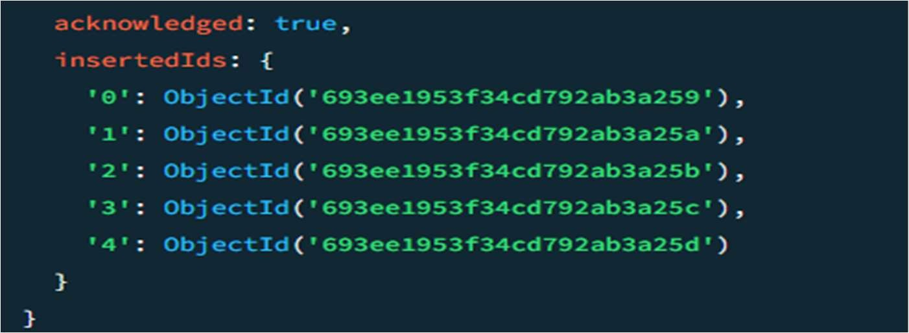

find all students:

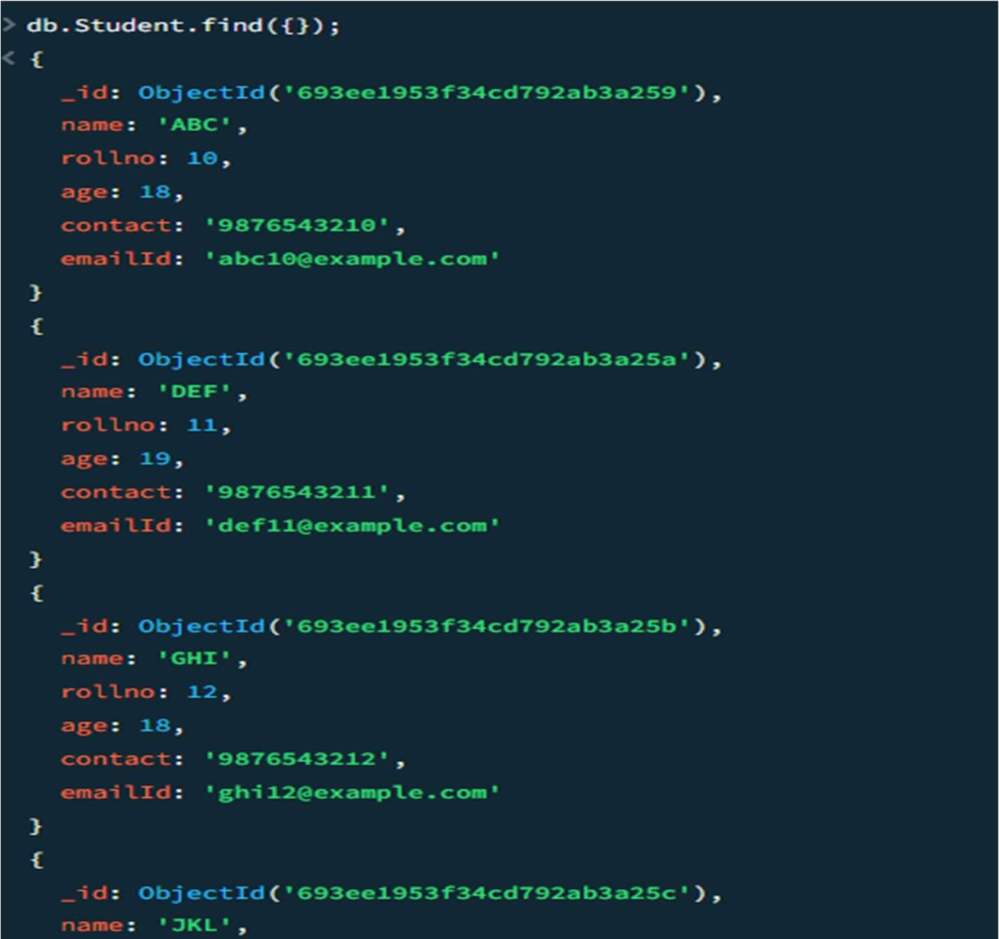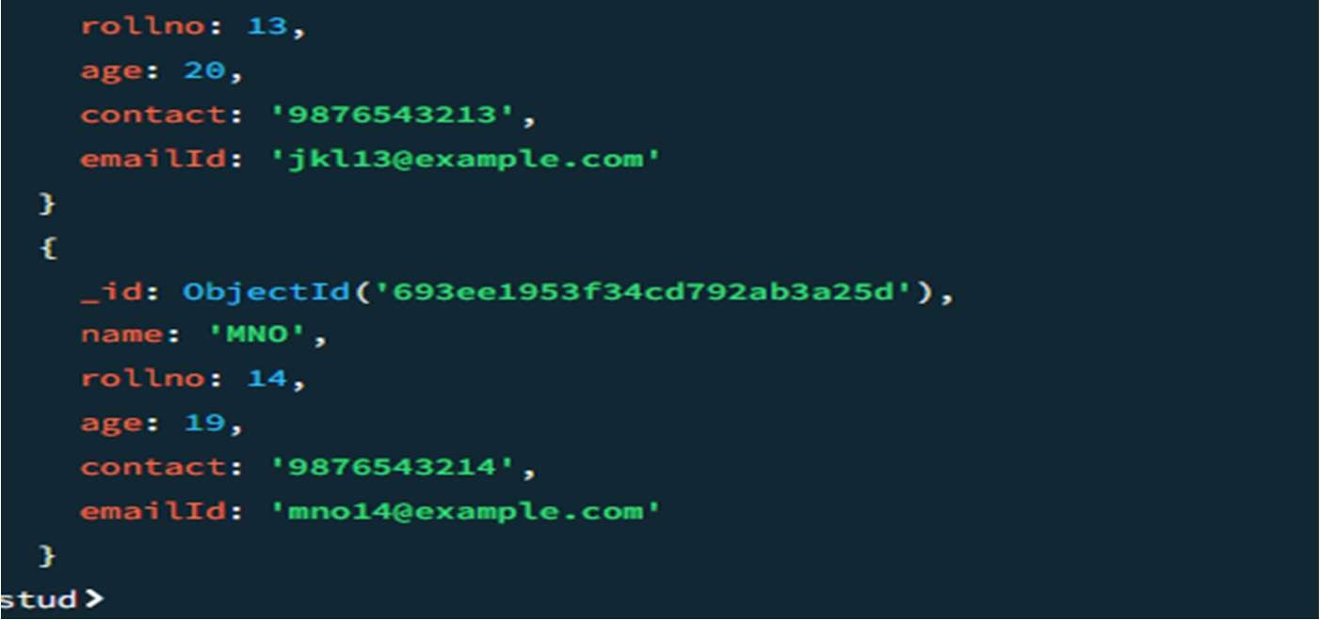

* Write query to update Email-Id of a student with rollno 10.

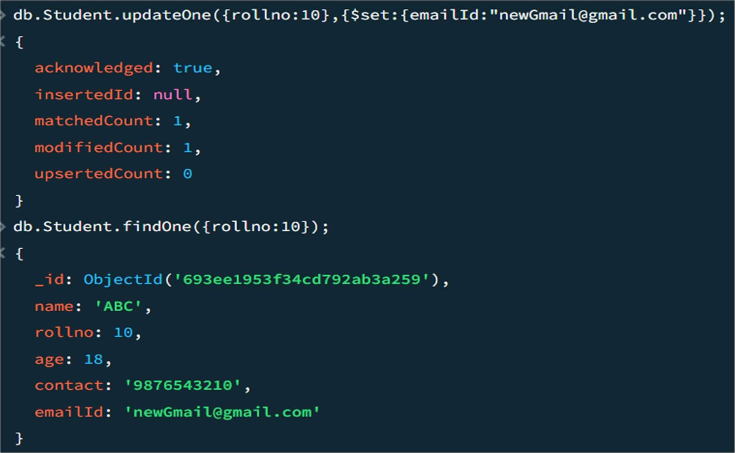

* Replace the student name from “DEF” to “FEM” of rollno 11.

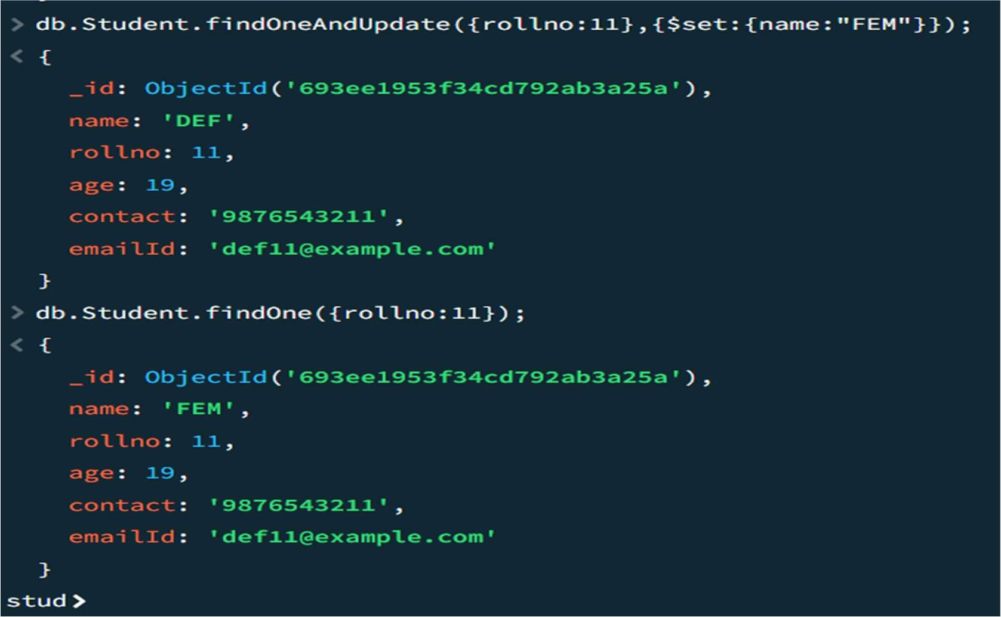

Drop the table.

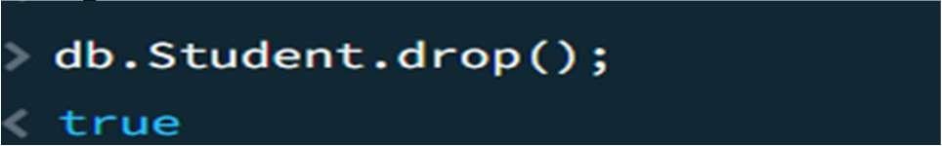

# Experiment 11: NoSQL Customer Database

create database customer; use customer; create collection named Customers;

db.createCollection(“Customers”);

inserting values :

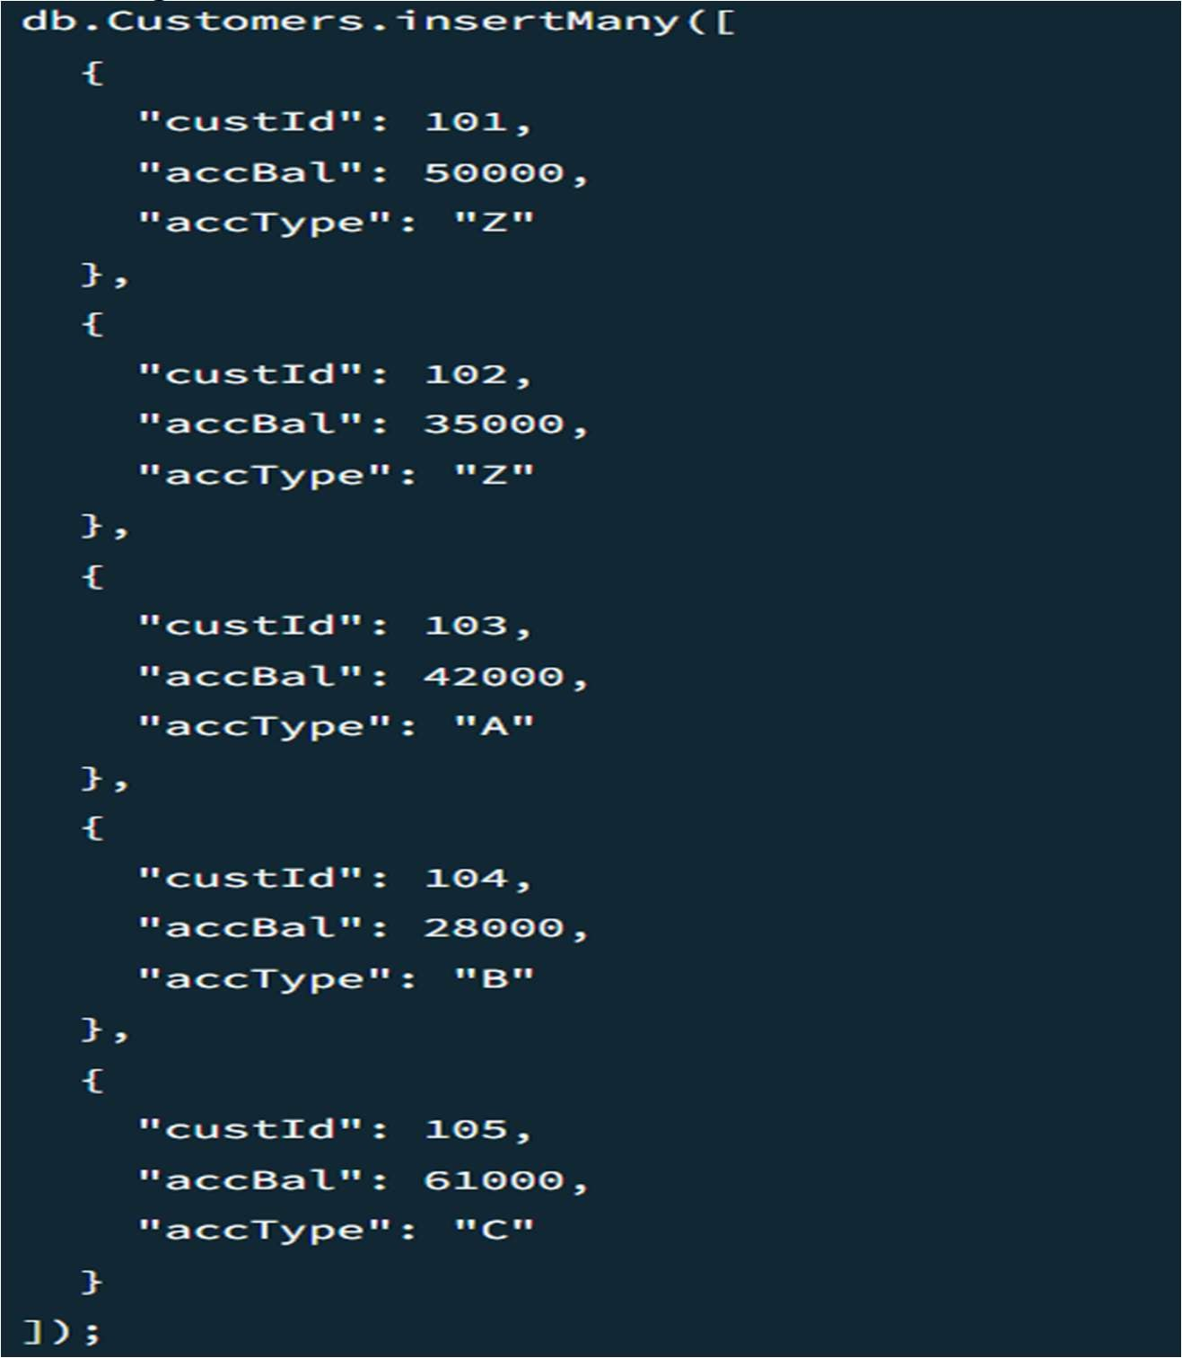

output:

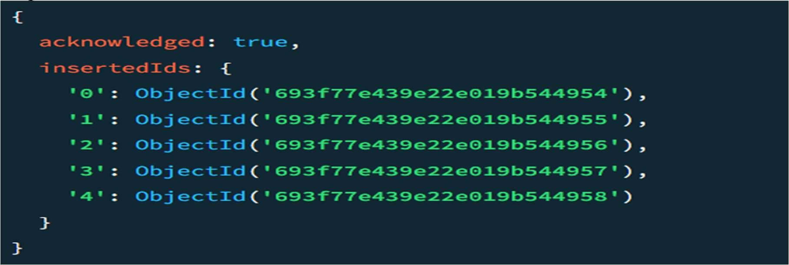 all customers

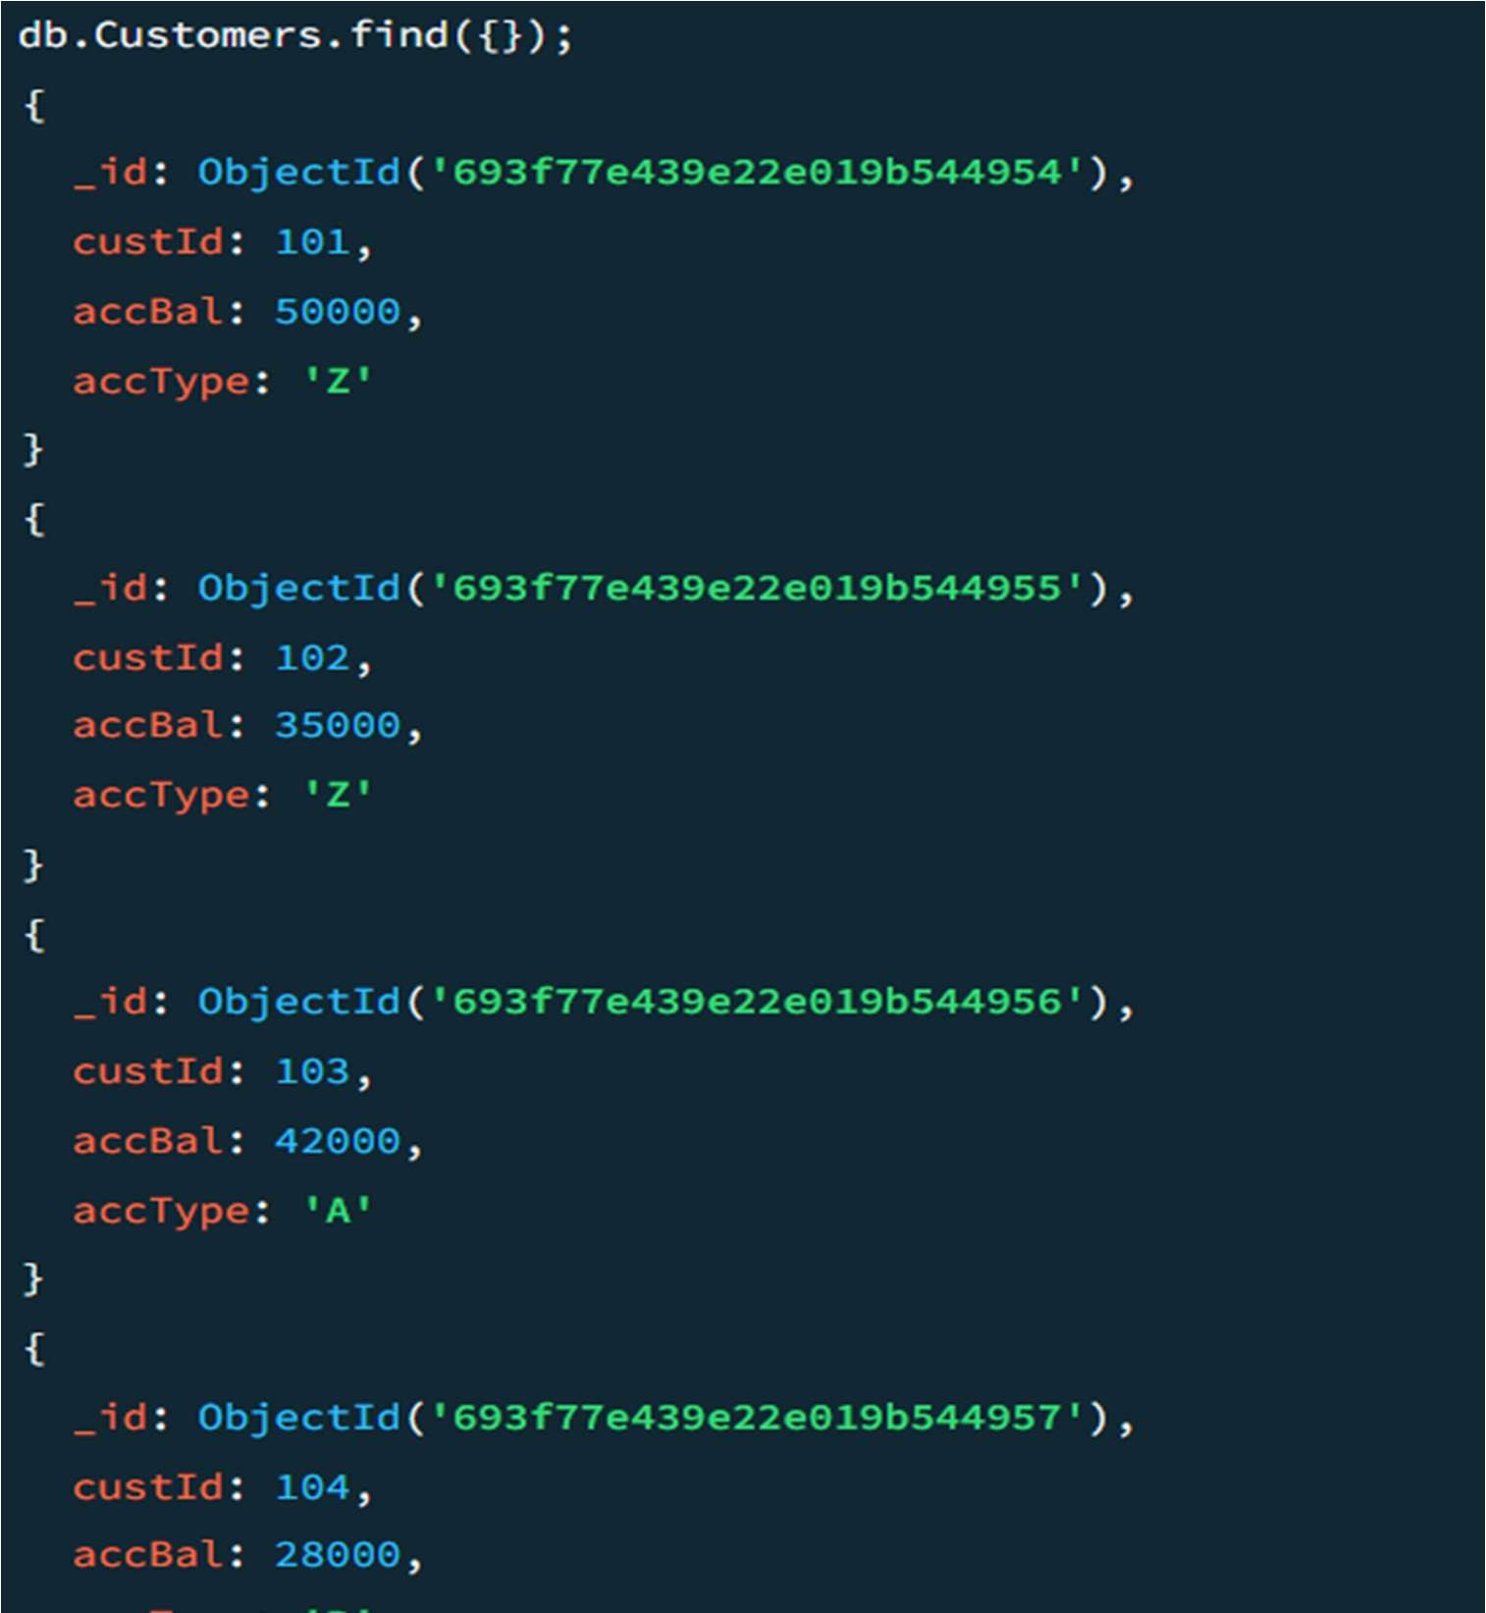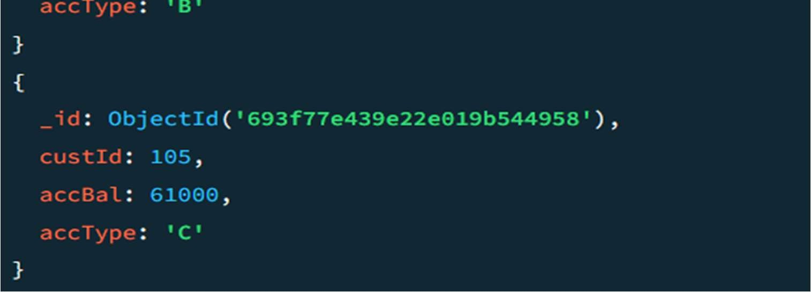

* Write a query to display those records whose total account balance is greater than 1200 of account type ‘Z’ for each customer_id.

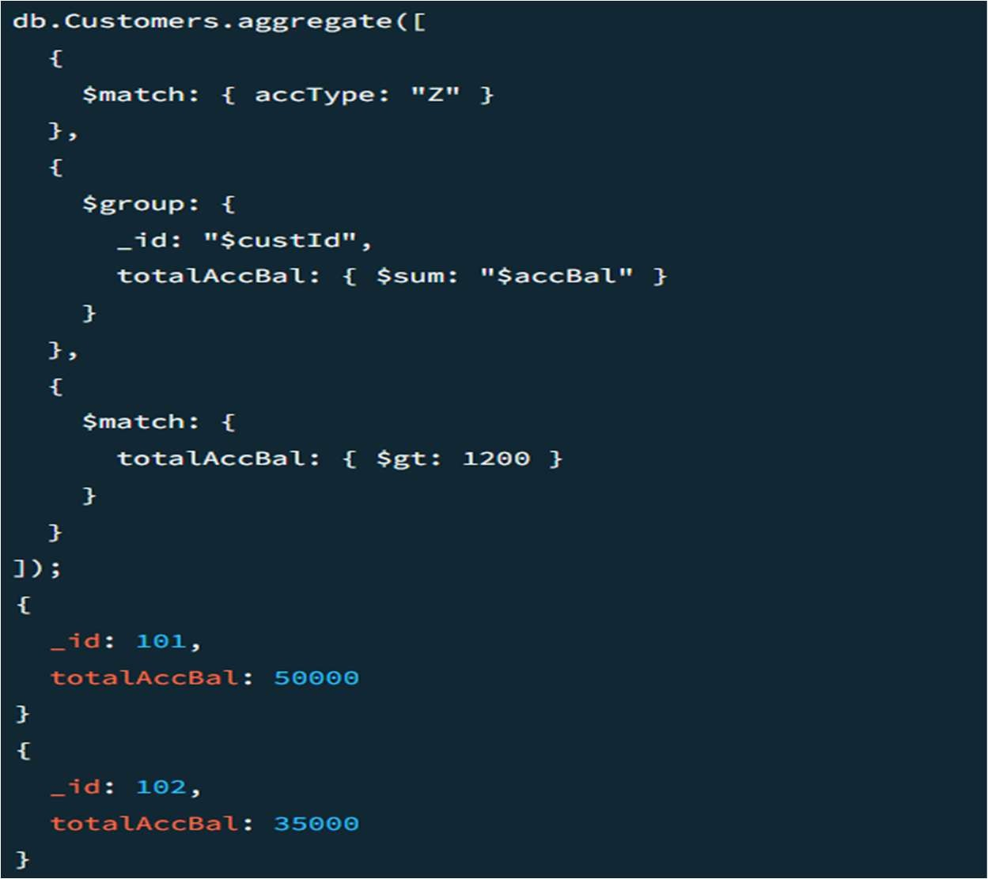

* Determine Minimum and Maximum account balance for each customer_id.

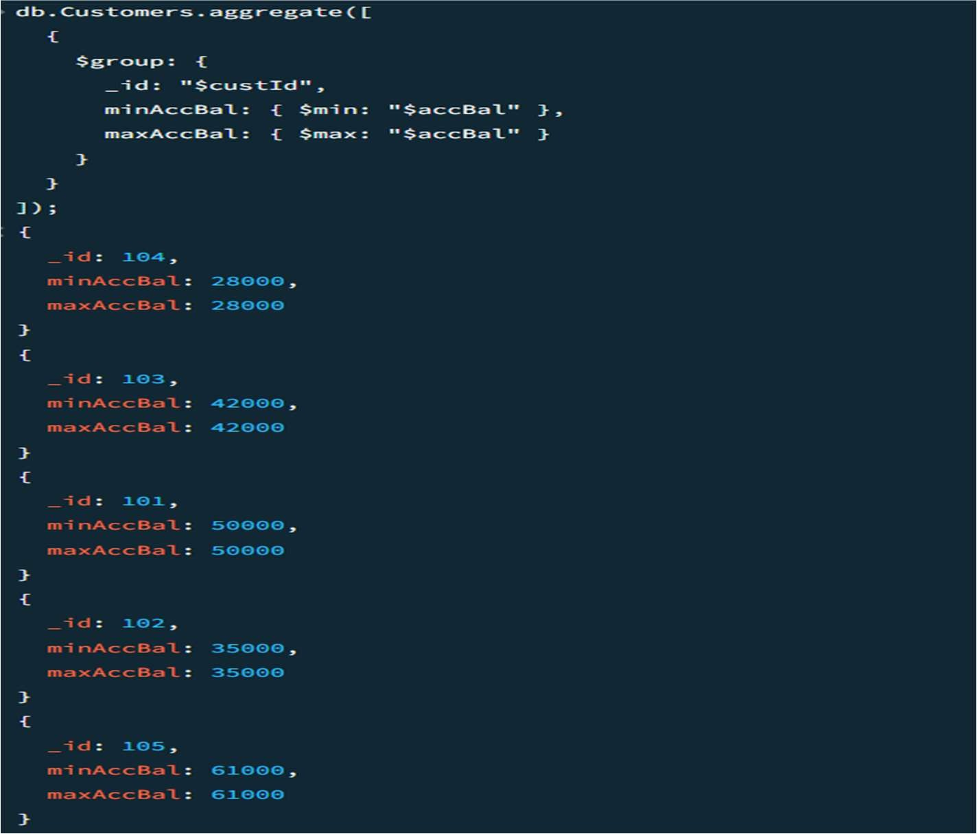

drop collection Customers;

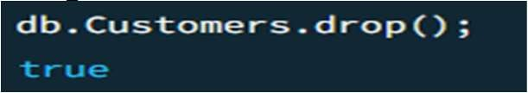

# Experiment 12: NoSQL Restaurant Database

create database Restaurant; create collection Restaurant:

db.createCollection(“Restaurant”);

Inserting value into collection;

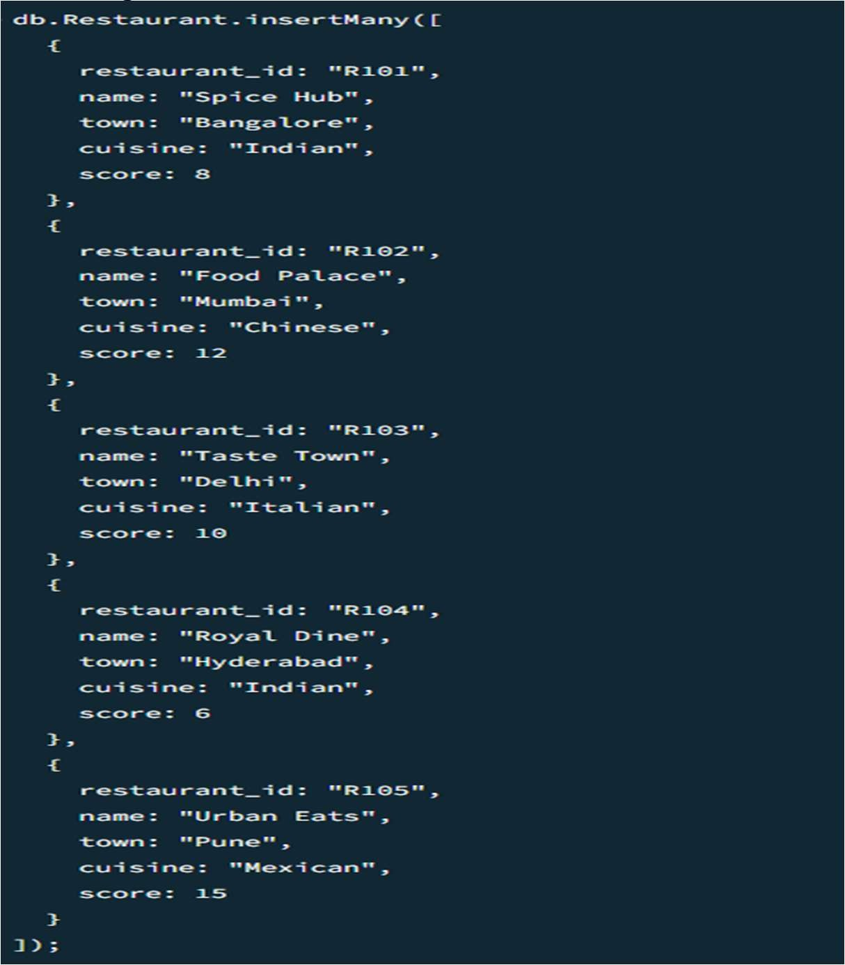

output:

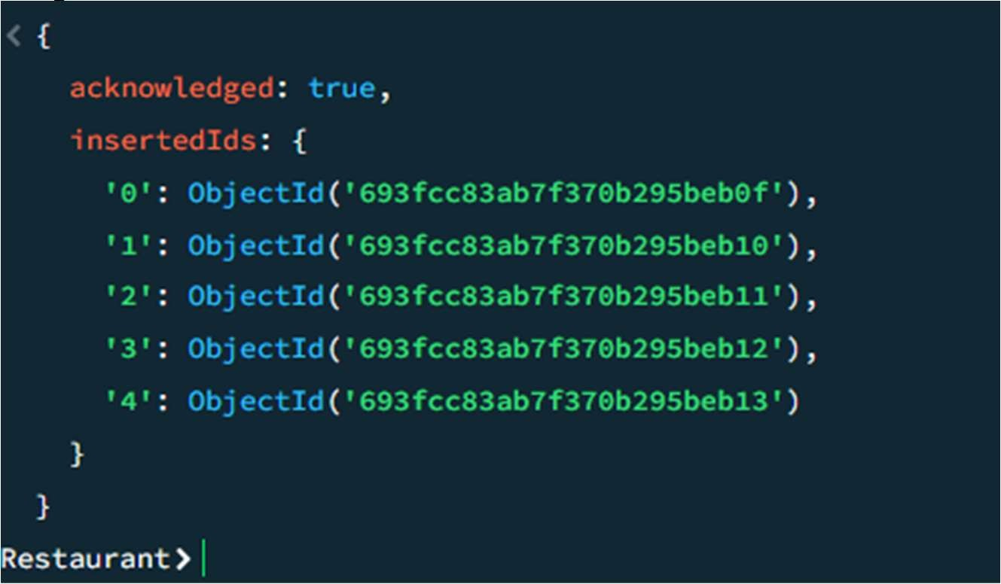

* Write a MongoDB query to display all the documents in the collection restaurants

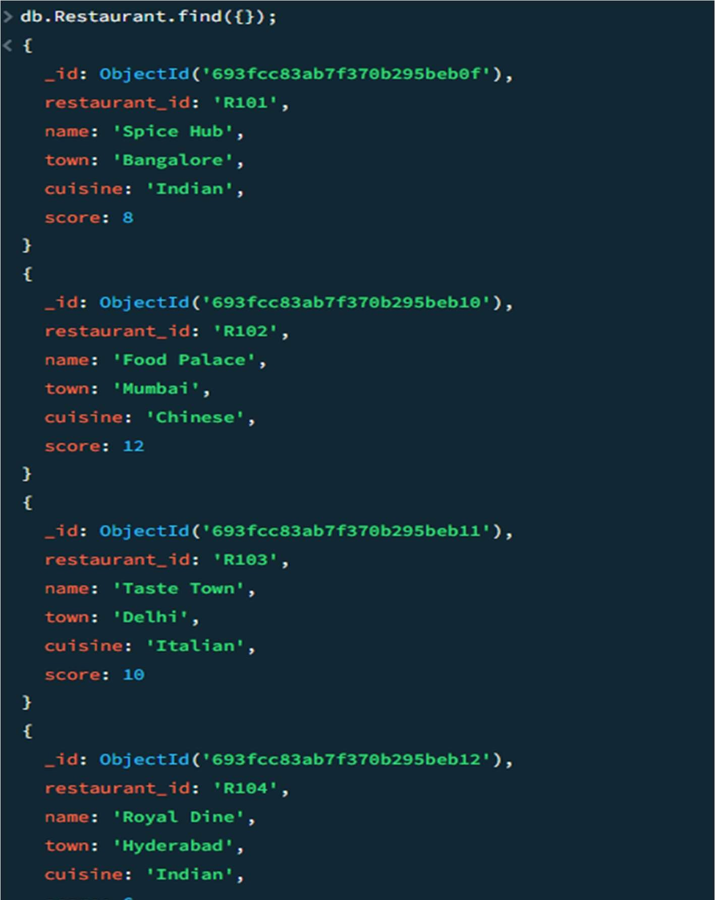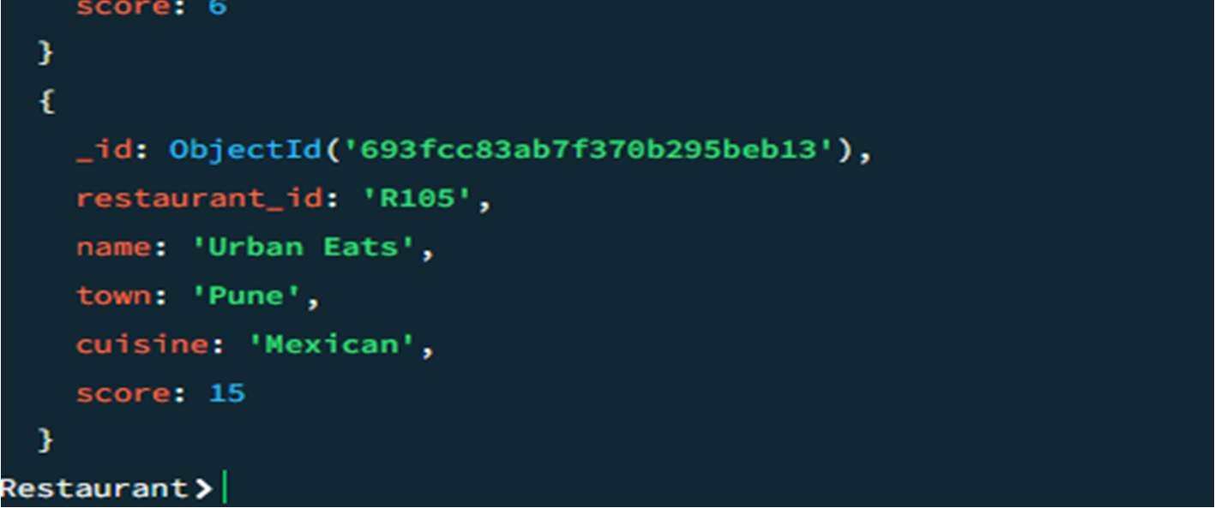

* Write a MongoDB query to arrange the name of the restaurants in descending along with all the columns.

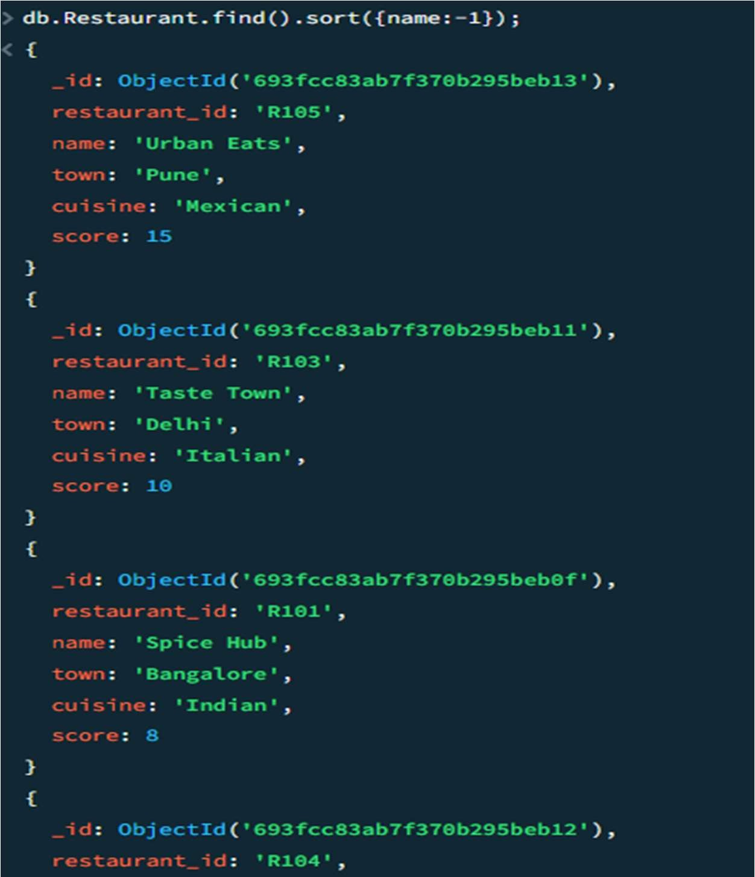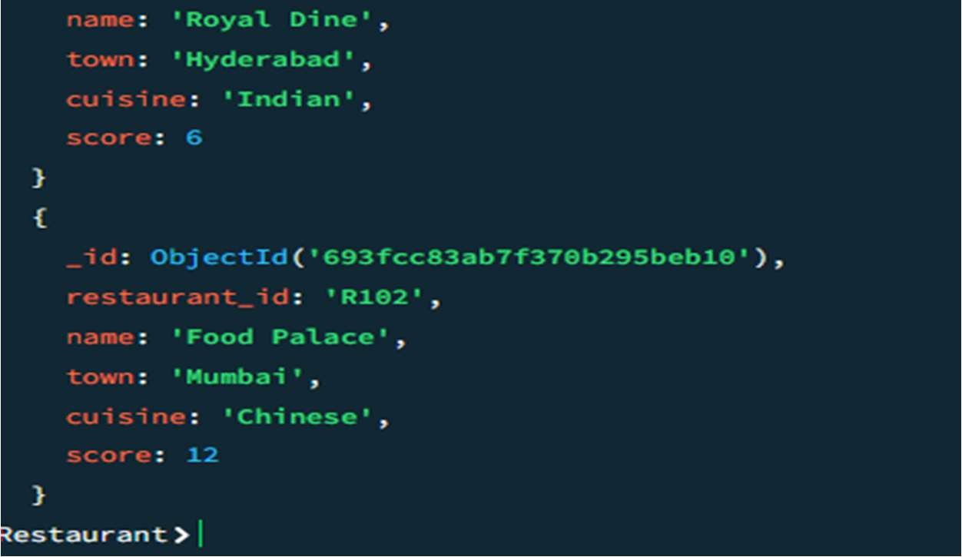

* Write a MongoDB query to find the restaurant Id, name, town and cuisine for those restaurants which achieved a score which is not more than 10.

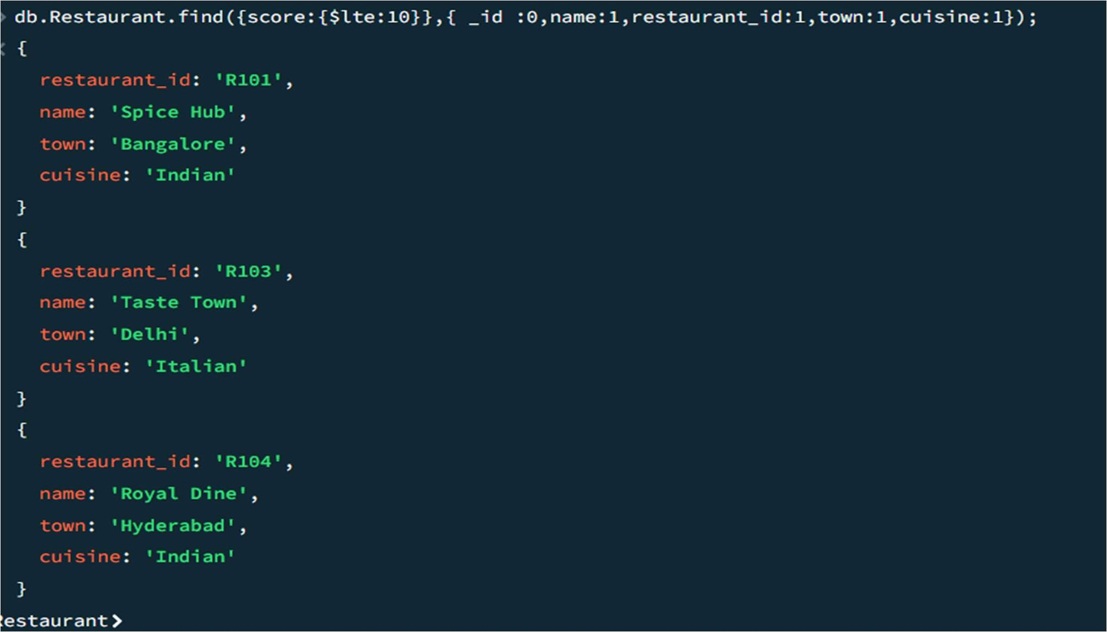

* Write a MongoDB query to find the average score for each restaurant.

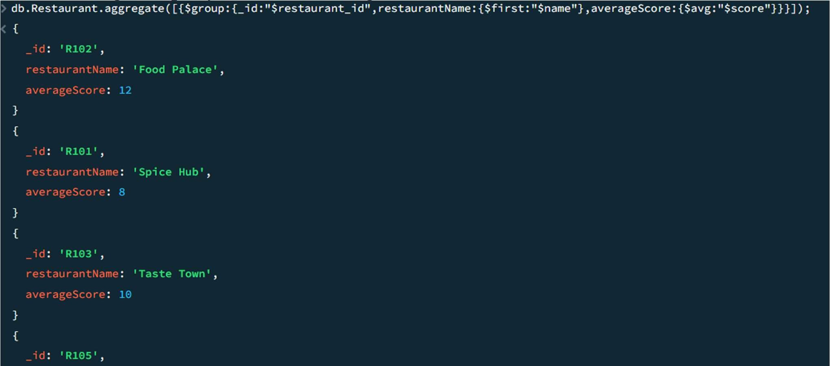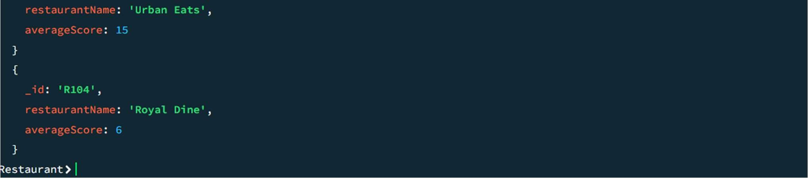

# Experiment 13: LeetCode Practice

1.Employee earning more than their manager

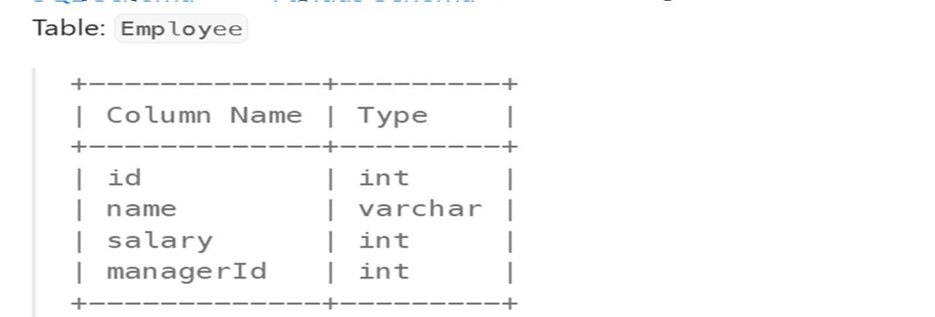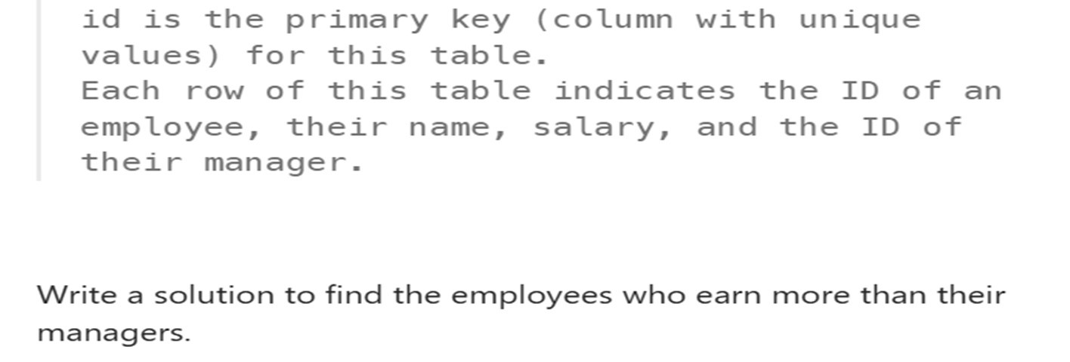

QUERY

select e.name as Employee from Employee e

where salary>( select salary from Employee

where id=e.managerId

);

OUT PUT:

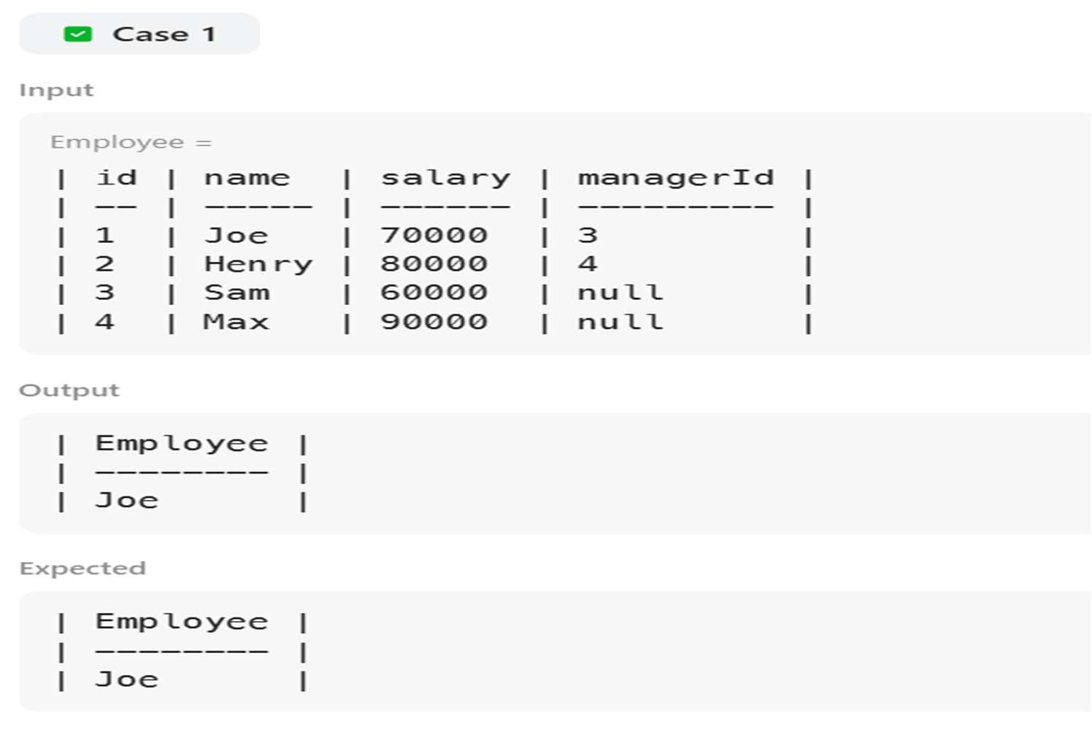

2.duplicate email

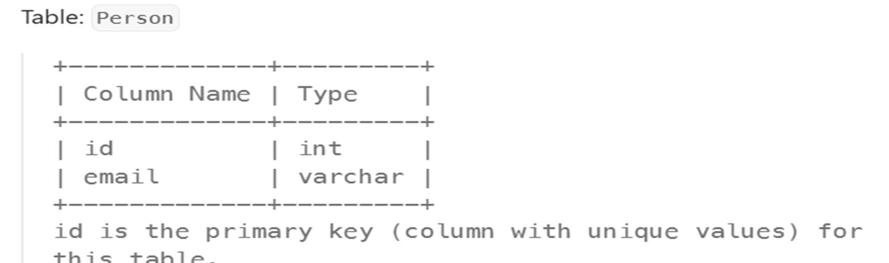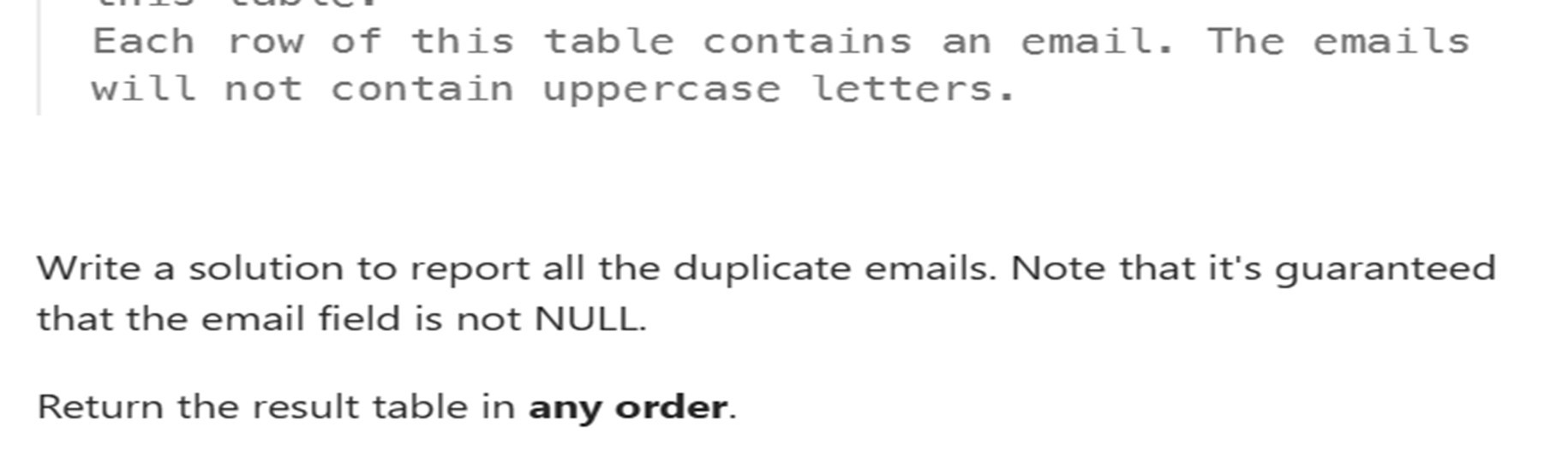

OUERY:

select email from Person where email is not null group by email having count(email)>1;

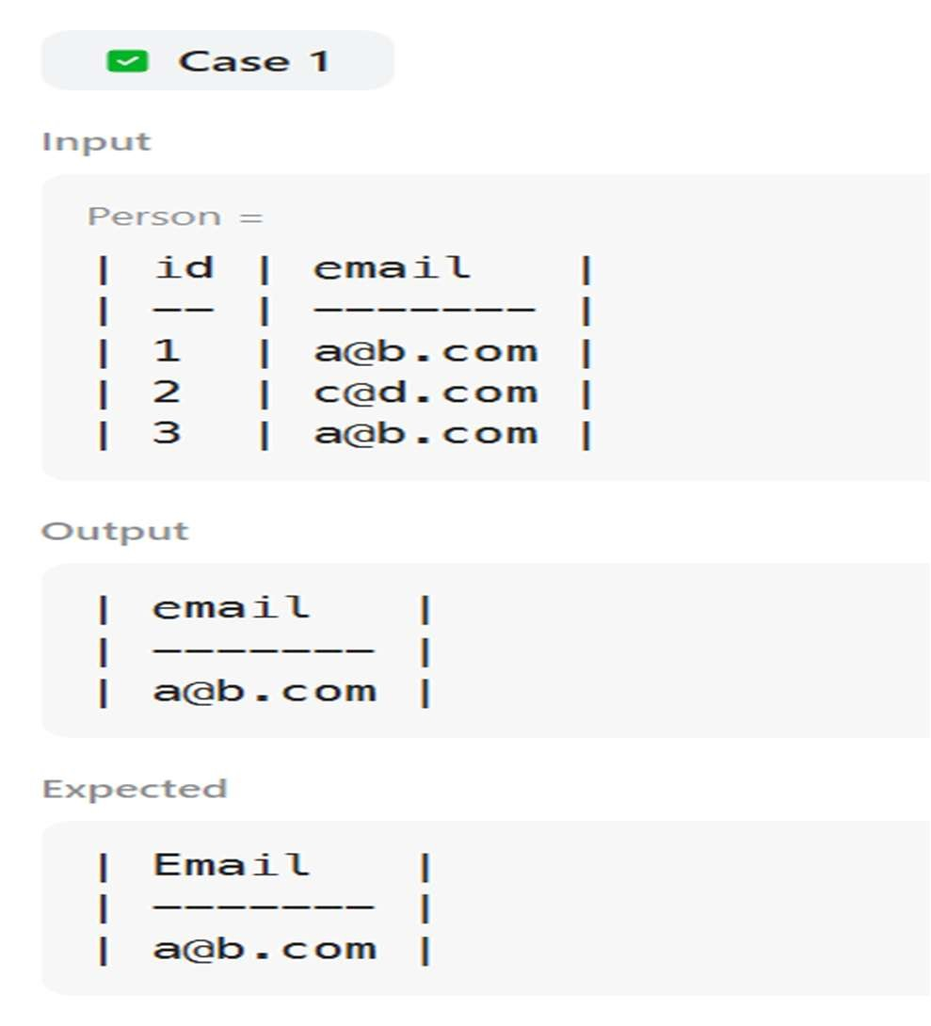

3.CUSTOMERS WHO NEVER ORDER

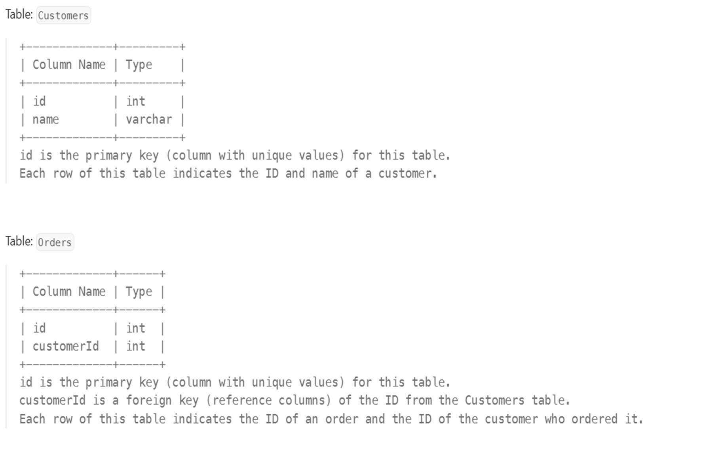 query:

select Customers.name as Customers from Customers left join Orders

on Customers.id=Orders.customerId where Orders.id is null output:

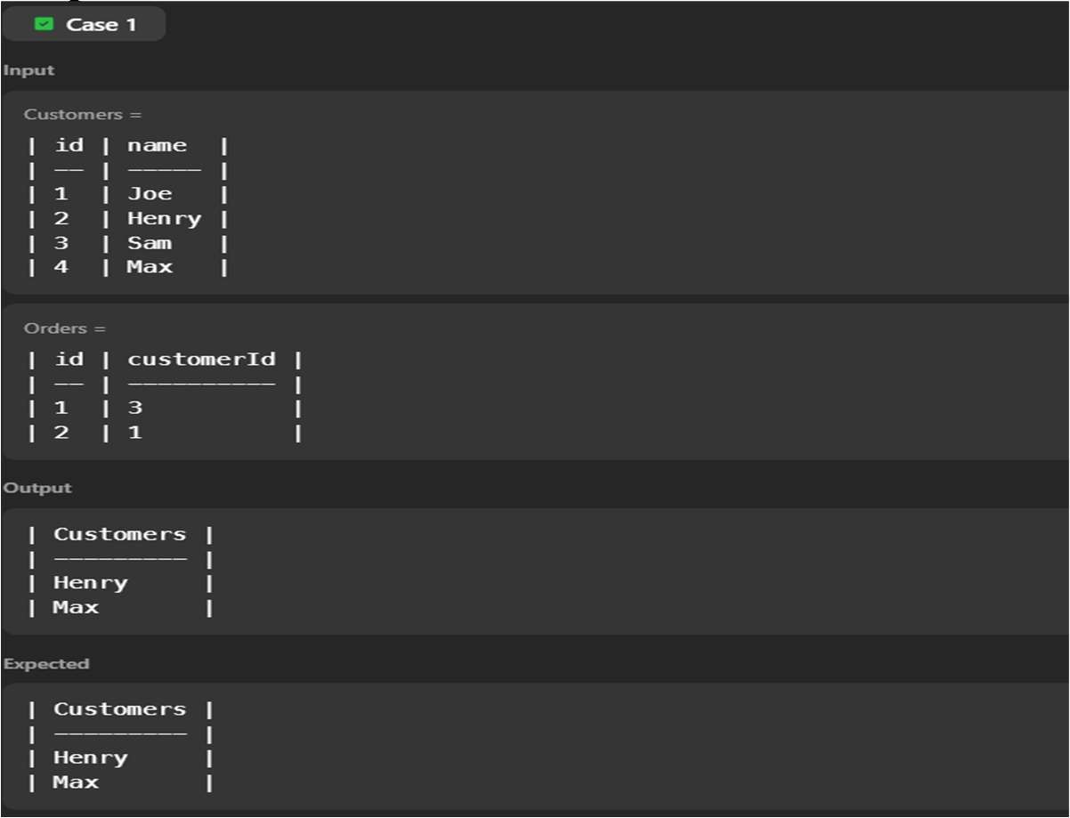

# Experiment 14: LeetCode Practice

1.GAME PLAY ANALYSIS 1

query:

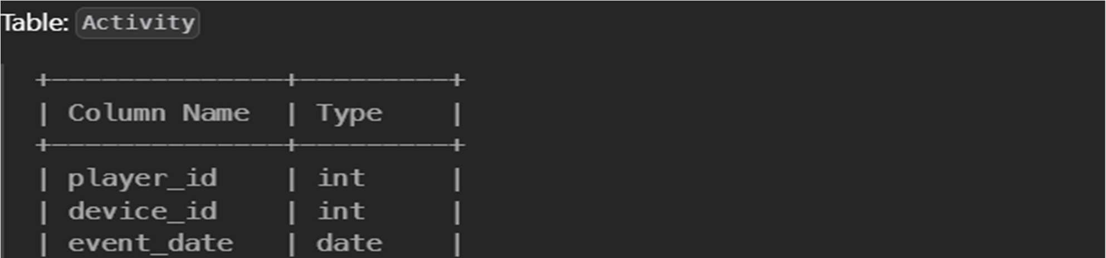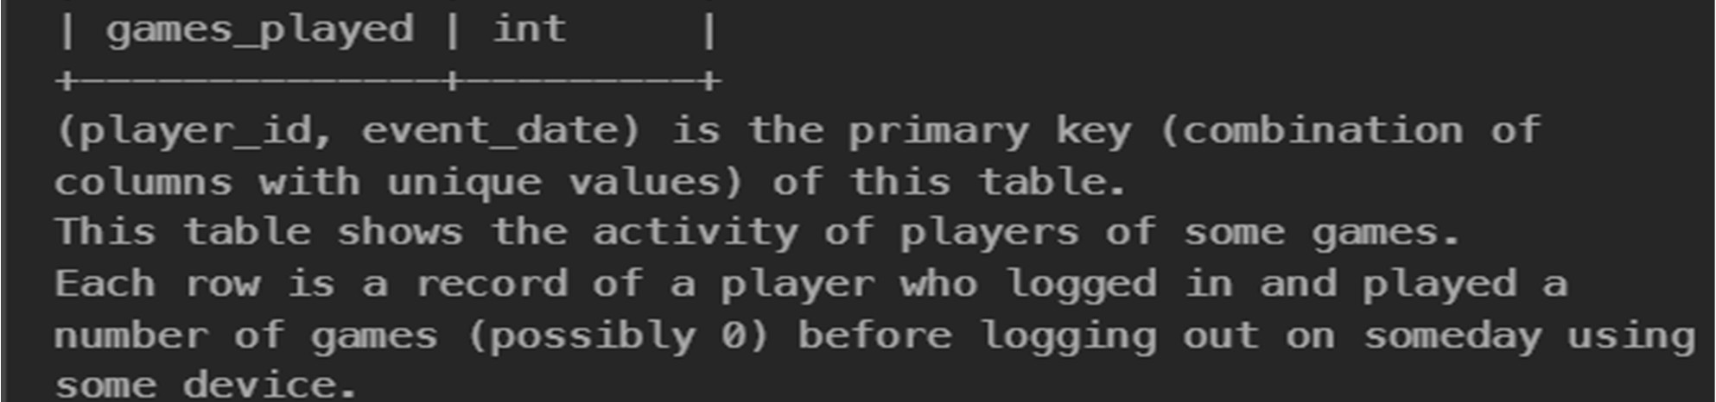

SELECT player_id,min(event_date) as first_login from Activity group by player_id

output:

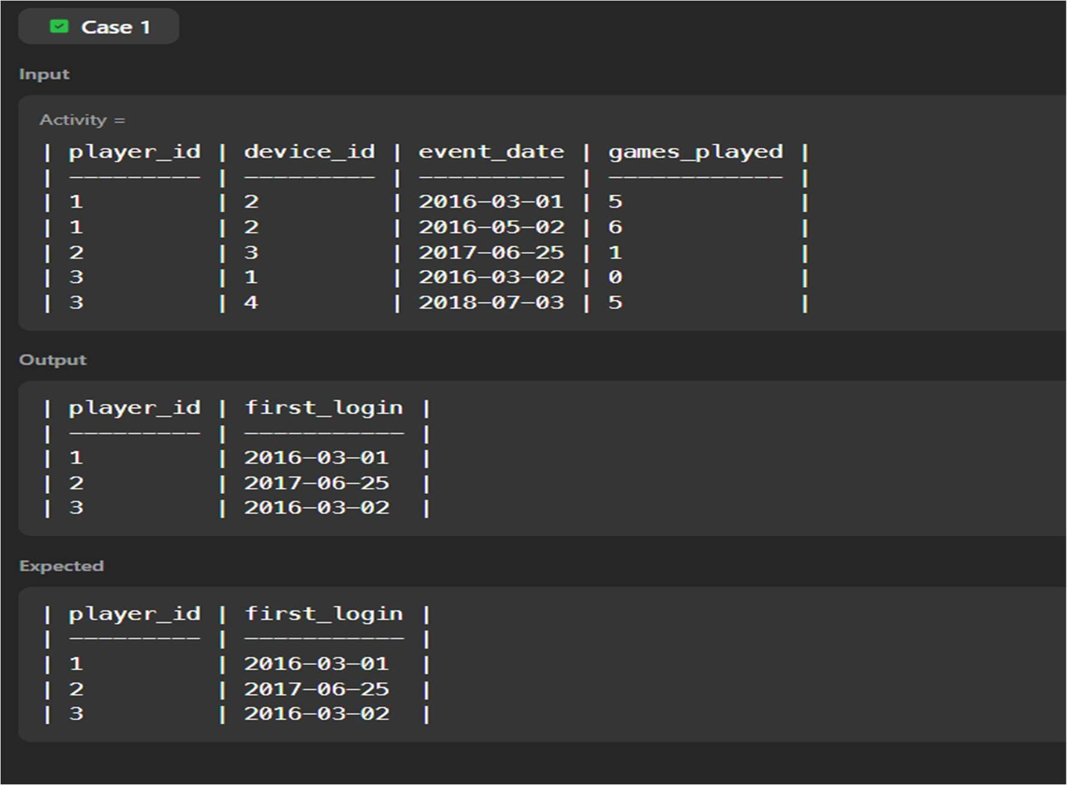

2.EMPLOYEE BONUS

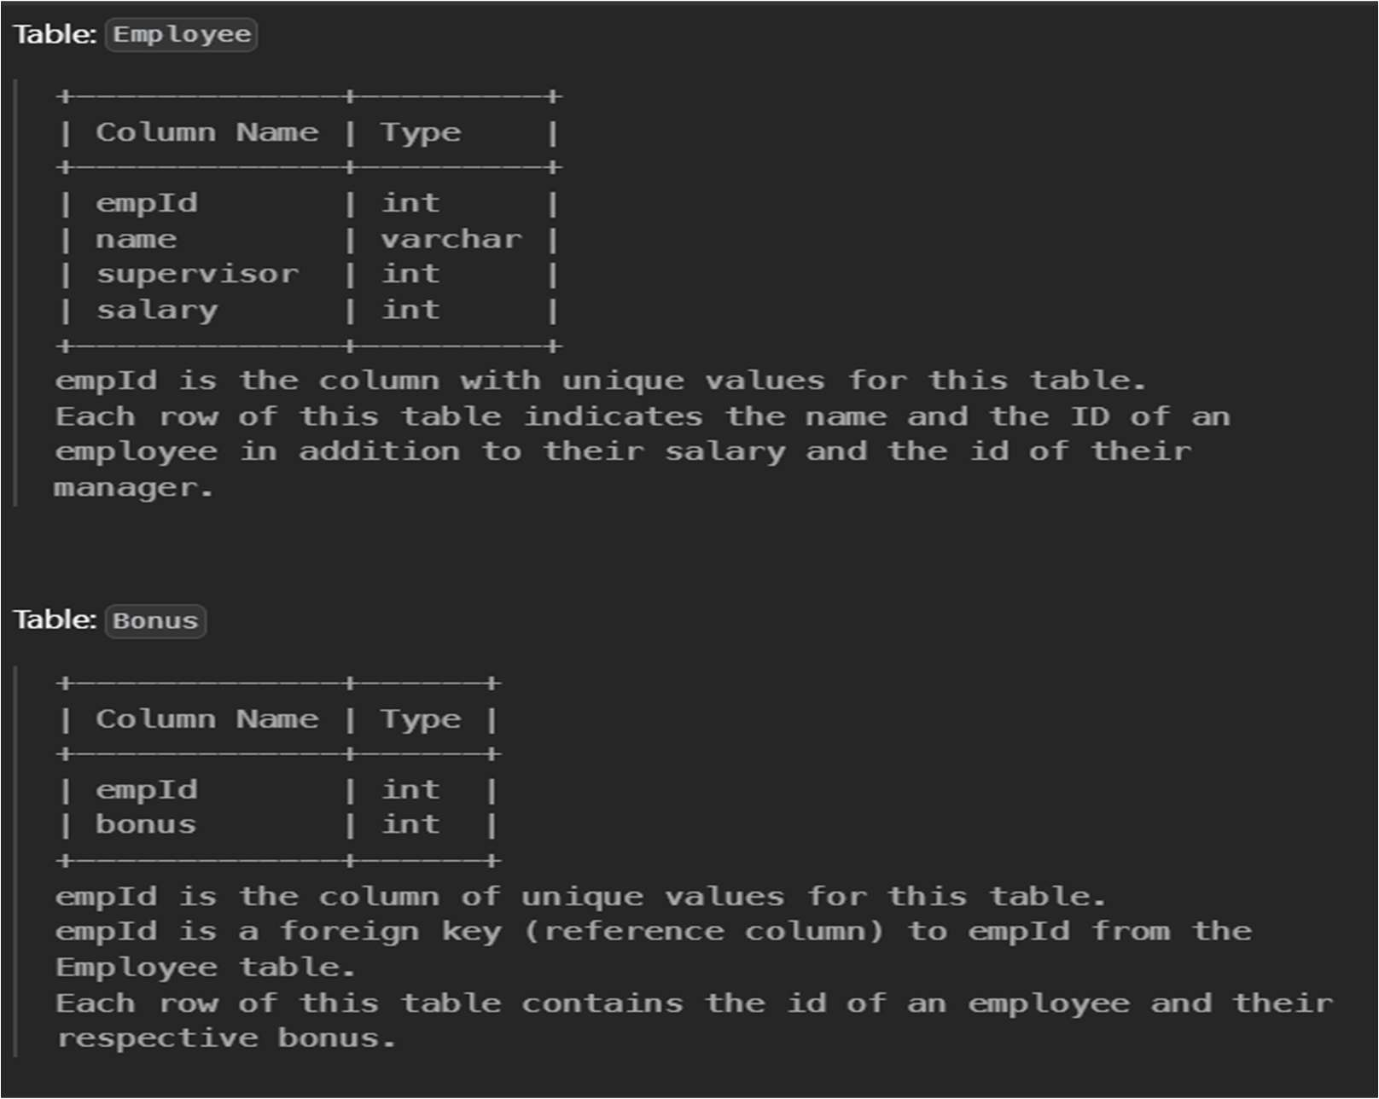

QUERY:

select E.name,B.bonus from Employee E left join Bonus B on E.empId=B.empId where B.bonus is null or b.bonus <1000;

OUTPUT:

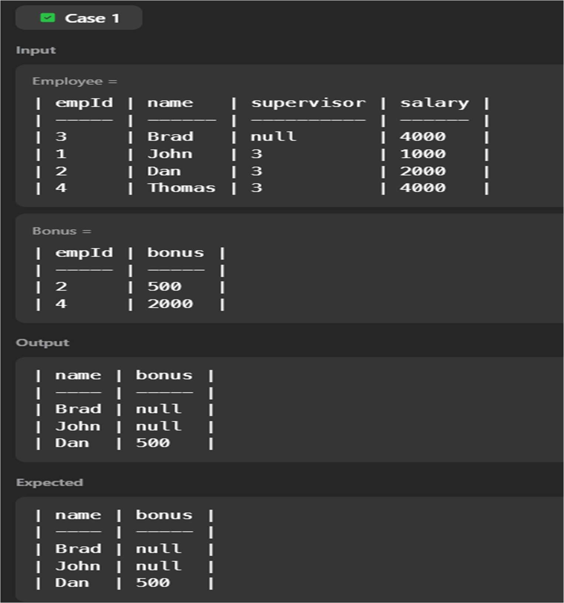

3.CLASSES WITH AT LEAST 5 STUDENTS

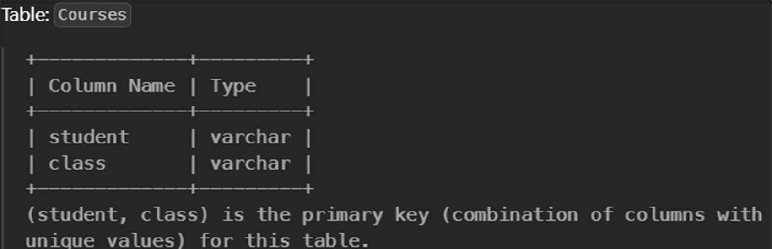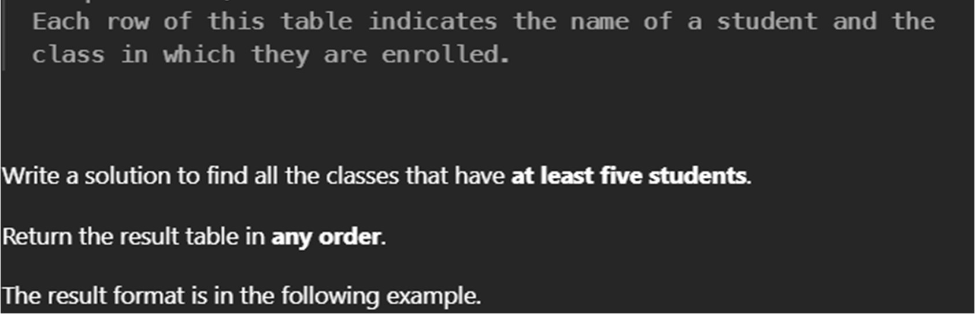

QUERY:

SELECT class FROM Courses GROUP BY class HAVING count(*)>=5;

OUTPUT:

